The Haz-Mat 1
40th Anniversary Challenge Coins
Are to commemorate our service in the FDNY. We chose to make only 343 coins to honor all our members lost on September 11, 2001.
The numbers on the coins have no numerical value and we make no distinction. However, we have pulled the numbers of the members of our house who died on 9/11; all other coins will be given to current or former members.
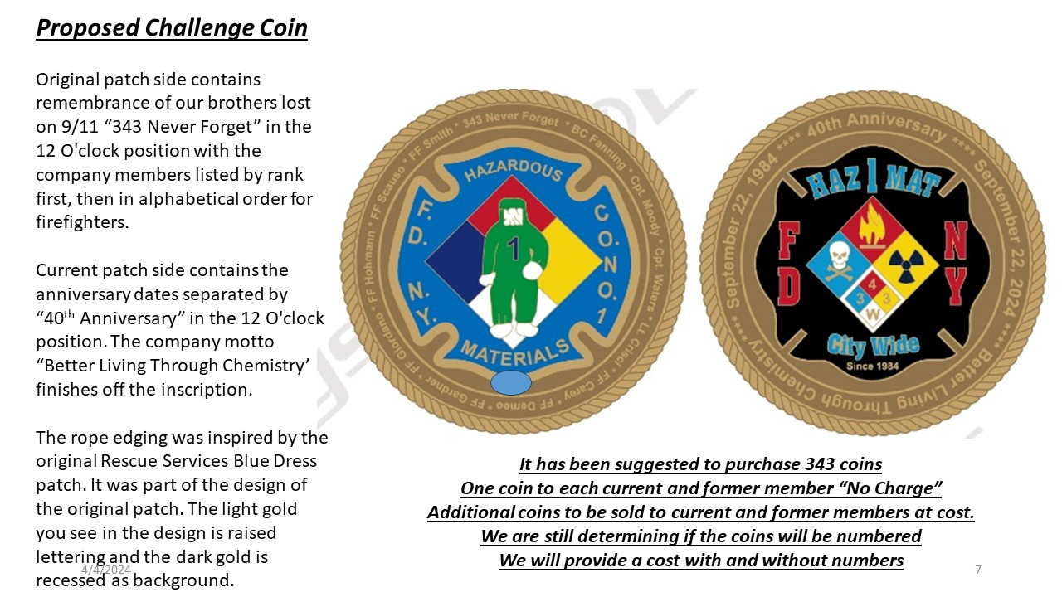

- Joseph Agnello, Lad.118
- Lt. Brian Ahearn, Bat.13
- Eric Allen, Sqd.18 (D)
- Richard Allen, Lad.15
- Capt. James Amato, Sqd.1
- Calixto Anaya Jr., Eng.4
- Joseph Angelini, Res.1 (D)
- Joseph Angelini Jr., Lad.4
- Faustino Apostol Jr., Bat.2
- David Arce, Eng.33
- Louis Arena, Lad.5 (D)
- Carl Asaro, Bat.9 Lt.
- Gregg Atlas, Eng.10
- Gerald Atwood, Lad.21
- Gerald Baptiste, Lad.9
- A.C. Gerard Barbara, Cmd. Ctr.
- Matthew Barnes, Lad.25
- Arthur Barry, Lad.15
- Lt. Steven Bates, Eng.235
- Carl Bedigian, Eng.214
- Stephen Belson, Bat.7
- John Bergin, Res.5
- Paul Beyer, Eng.6
- Peter Bielfeld, Lad.42
- Brian Bilcher, Sqd.1
- Carl Bini, Res.5
- Christopher Blackwell, Res.3
- Michael Bocchino, Bat.48
- Frank Bonomo, Eng.230
- Gary Box, Sqd.1
- Michael Boyle, Eng.33
- Kevin Bracken, Eng.40
- Michael Brennan, Lad.4
- Peter Brennan, Res.4
- Capt. Daniel Brethel, Lad.24 (D)
- Capt. Patrick Brown, Lad.3
- Andrew Brunn, Lad.5 (D)
- Capt. Vincent Brunton, Lad.105
- F.M. Ronald Bucca
- Greg Buck, Eng.201
- Capt. William Burke Jr., Eng.21
- A.C. Donald Burns, Cmd. Ctr.
- John Burnside, Lad.20
- Thomas Butler, Sqd.1
- Patrick Byrne, Lad.101
- George Cain, Lad.7
- Salvatore Calabro, Lad.101
- Capt. Frank Callahan, Lad.35
- Michael Cammarata, Lad.11
- Brian Cannizzaro, Lad.101
- Dennis Carey, Haz-Mat 1
- Michael Carlo, Eng.230
- Michael Carroll, Lad.3
- Peter Carroll, Sqd.1
- Thomas Casoria, Eng.22
- Michael Cawley, Lad.136
- Vernon Cherry, Lad.118
- Nicholas Chiofalo, Eng.235
- John Chipura, Eng.219
- Michael Clarke, Lad.2
- Steven Coakley, Eng.217
- Tarel Coleman, Sqd.252
- John Collins, Lad.25
- Robert Cordice, Sqd.1
- Ruben Correa, Eng.74
- James Coyle, Lad.3
- Robert Crawford, Safety
- Lt. John Crisci, Haz-Mat 1.
- B.C. Dennis Cross, Bat.57
- Thomas Cullen III, Sqd. 41
- Robert Curatolo, Lad.16
- Lt. Edward D'Atri, Sqd.1
- Michael D'Auria, Eng.40
- Scott Davidson, Lad.118
- Edward Day, Lad.11
- B.C. Thomas DeAngelis, Bat. 8
- Manuel Delvalle, Eng.5
- Martin DeMeo, Haz-Mat 1
- David DeRubbio, Eng.226
- Lt. Andrew Desperito, Eng.1
- B.C. Dennis Devlin, Bat.9
- Gerard Dewan, Lad.3
- George DiPasquale, Lad.2
- Lt. Kevin Donnelly, Lad.3
- Lt. Kevin Dowdell, Res.4
- B.C. Raymond Downey, Soc.
- Gerard Duffy, Lad.21
- Capt. Martin Egan, Jr., Div.15
- Michael Elferis, Eng.22
- Francis Esposito, Eng.235
- Lt. Michael Esposito, Sqd.1
- Robert Evans, Eng.33
- B.C. John Fanning, Haz-Mat Operations
- Capt. Thomas Farino, Eng.26
- Terrence Farrell, Res.4
- Capt. Joseph Farrelly, Div.1
- Dep. Comm. William Feehan,
- Lee Fehling, Eng.235
- Alan Feinberg, Bat.9
- Michael Fiore, Res.5
- Lt. John Fischer, Lad.20
- Andre Fletcher, Res.5
- John Florio, Eng.214
- Lt. Michael Fodor, Lad.21
- Thomas Foley, Res.3
- David Fontana, Sqd.1
- Robert Foti, Lad.7
- Andrew Fredericks, Sqd.18
- Lt. Peter Freund, Eng.55
- Thomas Gambino Jr., Res.3
- Chief of Dept. Peter Ganci, Jr.
- Lt. Charles Garbarini, Bat.9
- Thomas Gardner, Haz-Mat 1
- Matthew Garvey, Sqd.1
- Bruce Gary, Eng.40
- Gary Geidel, Res.1 B.C.
- Edward Geraghty, Bat.9
- Dennis Germain, Lad.2
- Lt. Vincent Giammona, Lad.5
- James Giberson, Lad.35
- Ronnie Gies, Sqd.288
- Paul Gill, Eng.54
- Lt. John Ginley, Eng.40
- Jeffrey Giordano, Lad.3
- John Giordano, Haz-Mat 1
- Keith Glascoe, Lad.21
- James Gray, Lad.20 B.C.
- Joseph Grzelak, Bat.48
- Jose Guadalupe, Eng.54
- Lt. Geoffrey Guja, Bat.43
- Lt. Joseph Gullickson, Lad.101
- David Halderman, Sqd.18
- Lt. Vincent Halloran, Lad.8
- Robert Hamilton, Sqd.41
- Sean Hanley, Lad.20
- Thomas Hannafin, Lad.5
- Dana Hannon, Eng.26
- Daniel Harlin, Lad.2
- Lt. Harvey Harrell, Res.5
- Lt. Stephen Harrell, Bat.7
- Capt. Thomas Haskell, Jr., Div.15
- Timothy Haskell, Sqd.18
- Capt. Terence Hatton, Res.1
- Michael Haub, Lad.4
- Lt. Michael Healey, Sqd.41
- John Hefferman, Lad.11
- Ronnie Henderson, Eng.279
- Joseph Henry, Lad.21
- William Henry, Res.1
- Thomas Hetzel, Lad.13
- Capt. Brian Hickey, Res.4 Lt.
- Timothy Higgins, S.O.C.
- Jonathan Hohmann, Haz-Mat 1
- Thomas Holohan, Eng.6
- Joseph Hunter, Sqd.288
- Capt. Walter Hynes, Lad.13
- Jonathan Ielpi, Sqd.288
- Capt. Frederick Ill Jr., Lad.2
- William Johnston, Eng.6
- Andrew Jordan, Lad.132
- Karl Joseph, Eng.207
- Lt. Anthony Jovic, Bat.47
- Angel Juarbe Jr., Lad.12
- Mychal Judge, Chaplain
- Vincent Kane, Eng.22 B.C.
- Charles Kasper, S.O.C.
- Paul Keating, Lad.5
- Richard Kelly Jr., Lad.11
- Thomas R. Kelly, Lad.15
- Thomas W. Kelly, Lad.105
- Thomas Kennedy, Lad.101
- Lt. Ronald Kerwin, Sqd.288
- Michael Kiefer, Lad.132
- Robert King Jr., Eng.33
- Scott Kopytko, Lad.15
- William Krukowski, Lad.21
- Kenneth Kumpel, Lad.25
- Thomas Kuveikis, Sqd.252
- David LaForge, Lad.20
- William Lake, Res.2
- Robert Lane, Eng.55
- Peter Langone, Sqd.252
- Scott Larsen, Lad.15 Lt.
- Joseph Leavey, Lad.15
- Neil Leavy, Eng.217
- Daniel Libretti, Res.2
- Carlos Lillo, Paramedic
- Robert Linnane, Lad.20
- Michael Lynch, Eng.40
- Michael Lynch, Lad.4
- Michael Lyons, Sqd.41
- Patrick Lyons, Sqd.252
- Joseph Maffeo, Lad.101
- William Mahoney, Res 4
- Joseph Maloney, Lad.3
- B.C. Joseph Marchbanks Jr, Bat.12
- Lt. Charles Margiotta, Bat.22
- Kenneth Marino, Res.1
- John Marshall, Eng.23 Lt.
- Peter Martin, Res.2
- Lt. Paul Martini, Eng.23
- Joseph Mascali, T.S.U. 2
- Keithroy Maynard, Eng.33
- Brian McAleese, Eng.226
- John McAvoy, Lad.3
- Thomas McCann, Bat.8
- Lt. William McGinn, Sqd.18
- B.C. William McGovern, Bat.2
- Dennis McHugh, Lad.13
- Robert McMahon, Lad.20
- Robert McPadden, Eng.23
- Terence McShane, Lad.101
- Timothy McSweeney, Lad.3
- Martin McWilliams, Eng.22
- Raymond Meisenheimer, Res.3
- Charles Mendez, Lad.7
- Steve Mercado, Eng.40
- Douglas Miller, Res.5
- Henry Miller Jr, Lad.105
- Robert Minara, Lad.25
- Thomas Mingione, Lad.132
- Lt. Paul Mitchell, Bat.1
- Capt. Louis Modafferi, Res.5
- Lt. Dennis Mojica, Res.1
- Manuel Mojica, Sqd.18
- Carl Molinaro, Lad.2
- Michael Montesi, Res.1
- Capt. Thomas Moody, Div.1
- B.C. John Moran, Bat.49
- Vincent Morello, Lad.35
- Christopher Mozzillo, Eng.55
- Richard Muldowney Jr, Lad.07
- Michael Mullan, Lad.12
- Dennis Mulligan, Lad.2
- Lt. Raymond Murphy, Lad.16
- Lt. Robert Nagel, Eng.58
- John Napolitano, Res.2
- Peter Nelson, Res.4
- Gerard Nevins, Res.1
- Dennis O'Berg, Lad.105
- Lt. Daniel O'Callaghan, Lad.4
- Douglas Oelschlager, Lad.15
- Joseph Ogren, Lad.3
- Lt. Thomas O'Hagan, Bat.4
- Samuel Oitice, Lad.4
- Patrick O'Keefe, Res.1
- Capt. William O'Keefe, Div.15
- Eric Olsen, Lad.15
- Jeffery Olsen, Eng.10
- Steven Olson, Lad.3
- Kevin O'Rourke, Res.2
- Michael Otten, Lad.35
- Jeffery Palazzo, Res.5
- B.C. Orio Palmer, Bat.7
- Frank Palombo, Lad.105
- Paul Pansini, Eng.10
- B.C. John Paolillo, Bat.11
- James Pappageorge, Eng.23
- Robert Parro, Eng.8
- Durrell Pearsall, Res.4
- Lt. Glenn Perry, Bat.12
- Lt. Philip Petti, Bat.7
- Lt. Kevin Pfeifer, Eng. 33
- Lt. Kenneth Phelan, Bat.32
- Christopher Pickford, Eng.201
- Shawn Powell, Eng.207
- Vincent Princiotta, Lad.7
- Kevin Prior, Sqd.252
- B.C. Richard Prunty, Bat.2
- Lincoln Quappe, Res.2
- Lt. Michael Quilty, Lad.11
- Ricardo Quinn, Paramedic
- Leonard Ragaglia, Eng.54
- Michael Ragusa, Eng.279
- Edward Rall, Res.2
- Adam Rand, Sqd.288
- Donald Regan, Res.3
- Lt. Robert Regan, Lad.118
- Christian Regenhard, Lad.131
- Kevin Reilly, Eng.207
- Lt. Vernon Richard, Lad.7
- James Riches, Eng.4
- Joseph Rivelli, Lad.25
- Michael Roberts, Eng.214
- Michael E. Roberts, Lad.35
- Anthony Rodriguez, Eng.279
- Matthew Rogan, Lad.11
- Nicholas Rossomando, Res.5
- Paul Ruback, Lad.25
- Stephen Russell, Eng.55
- Lt. Michael Russo, S.O.C.
- B.C. Matthew Ryan, Bat.1
- Thomas Sabella, Lad.13
- Christopher Santora, Eng.54
- John Santore, Lad.5
- Gregory Saucedo, Lad.5
- Dennis Scauso, Haz-Mat 1
- John Schardt, Eng.201
- B.C. Fred Scheffold, Bat.12
- Thomas Schoales, Eng.4
- Gerard Schrang, Res.3
- Gregory Sikorsky, Sqd.41
- Stephen Siller, Sqd.1
- Stanley Smagala Jr, Eng.226
- Kevin Smith, Haz-Mat 1
- Leon Smith Jr, Lad 118
- Robert Spear Jr, Eng.26
- Joseph Spor, Res.3
- B.C. Lawrence Stack, Bat.50
- Capt. Timothy Stackpole, Div.11
- Gregory Stajk, Lad.13
- Jeffery Stark, Eng.230
- Benjamin Suarez, Lad.21
- Daniel Suhr, Eng.216
- Lt. Christopher Sullivan, Lad.111
- Brian Sweeney, Res.1
- Sean Tallon, Lad.10
- Allan Tarasiewicz, Res.5
- Paul Tegtmeier, Eng.4
- John Tierney, Lad.9
- John Tipping II, Lad.4
- Hector Tirado Jr, Eng.23
- Richard Vanhine, Sqd.41
- Peter Vega, Lad.118
- Lawrence Veling, Eng.235
- John Vigiano II, Lad.132
- Sergio Villanueva, Lad.132
- Lawrence Virgilio, Sqd.18
- Lt. Robert Wallace, Eng.205
- Jeffery Walz, Lad. 9
- Lt. Michael Warchola, Lad.5
- Capt. Patrick Waters, S.O.C.
- Kenneth Watson, Eng.214
- Michael Weinberg, Eng.1
- David Weiss, Res.1
- Timothy Welty, Sqd.288
- Eugene Whelan, Eng.230
- Edward White, Eng.230
- Mark Whitford, Eng.23
- Lt. Glenn Wilkinson, Eng.238
- B.C. John Williamson, Bat.6
- Capt. David Wooley, Lad.4
- Raymond York, Eng.285

HIGHLIGHTS (coin numbers to hold)
Haz-Mat 1 members Squad Members Other Possible holds

