_,.
BP-166 ( 1/71) REPORT OF MERITORIOUS ACT October 2, 1989
Dote

l. BOX 33-0037
(highest olorm}.
BOROUGH
Q�u_e_e�n=s�_ TIME 232
4_

- PERFORMED BY: Lieutenant Alberts. Warta Batt. 46
Ronk er Grode Nome Unit Assigned
Haz Mat Co. #1
Detailed

- DID ANY OTHER MEMBER PARTICIPATE DIRECTLY IN THIS ACT' FF-1 Kevin Smith Haz Mat Co. #1
(IF Yes}_ FF-1 . Carl Eeilmoser Rescue Liaison
Rank Name Unit

Is Meritorious Act Report being forwarded for participating member? Yes
_ If not, how did

member particip ace?

- LOCATION OF MERITORIOUS ACT
  - If in building: Address

Height
Area _ _
building _ _ _
Construction
_
_

Floor where acc. took place-�----- Room _ __
  - If not in building: Give complete descriptive iriformation so that physical setting can be recreated.An Airplane down in the water at the and of the runway
at LaGuardia Airport.

- PERS ON (S} AIDED:
NAME Sue Peterson Ann Crews
ADDRESS South Carolina Danville, Virginia
AGE - SEX Female 25 Yrs Old Female 62 Yrs Old
RESCUE BRE ATHING EXTERNAL CARDIAC MASS AGE RESUSCITATOR APPLIED  HOSP ITALIZED | No No  No No  No No  Yes Yes
NAME OF HOSPITAL | Jamaica Hospital | Jamaica Hospital
DIAGNOSIS | Lacerations | Broken Wrist
LENGTH OF HOSPITALIZ ATION | 9 Days I | 1 Day

- MEMBER PERFORMING ACT: Did he receive any emergency treatment? Y-e-s ------------- Specify_ Hydraulic fluid in eyes, and jet fuel on body
Was medical leave granted ? Yes
-��
WHAT SPECIFIC JOB WAS MEMBER PERFORMING AT TIME OF RESCUE?
--=
7. --E-xt-r-ic-a-ti-o-n ---------
WAS MEMBER ALONE?_
area,
and describe their positions in# 11.
Na
( If not, indicate number of
Fire Department personnel
in immediate
WAS A MASK WORN BY MEMBER DURING RESCUE?
NA_ _________
_
_

HOW WAS VICTIM REMOVED FROM PREMISES? Carried _ Dragged____ Assisted -Y-e-s ---
WAS CHARGED HOSE LINE IN POSITION
TO PROTECT MEMBER MAKING RESCUE?
NA

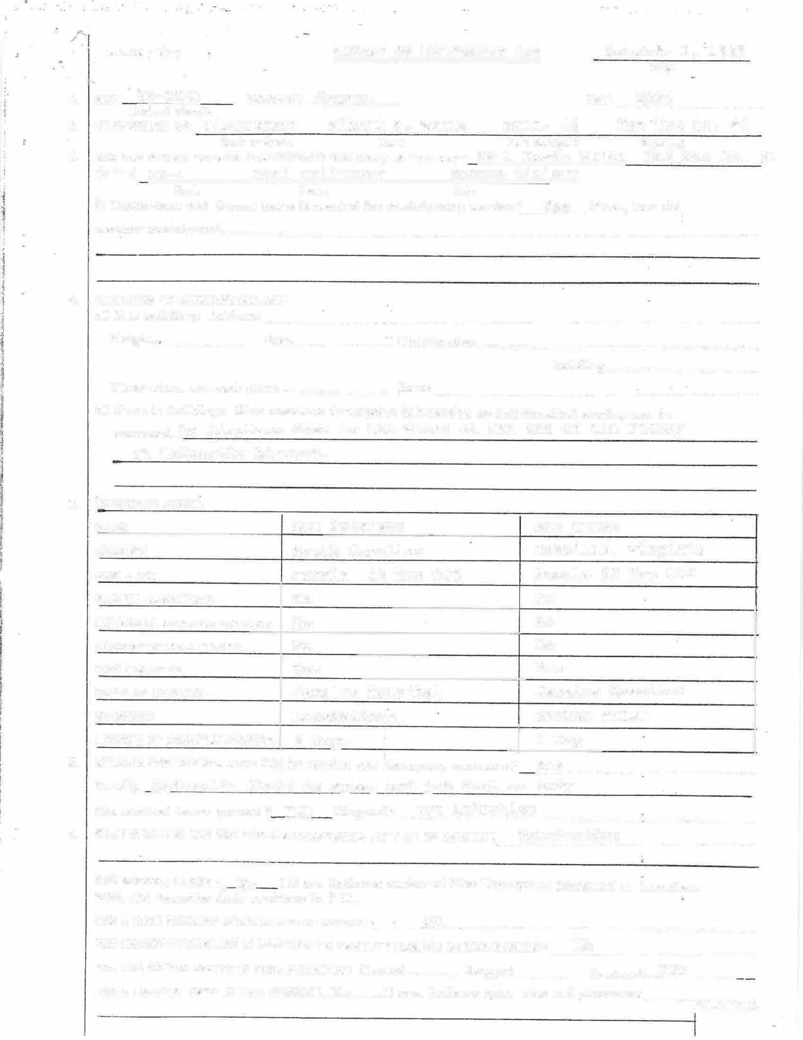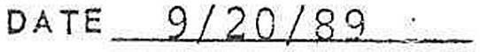WAS A LADDER USED IN THIS RESCUE ?_N�a�
[f yes, indicate cvpe, size and placement ,... _-_-_-.:::.:::::-_

- 2 -
REPORT OF MERITORIOUS ACT

- NAME(S} OF TWO MEMBERS WHO AC.TUALLY WITNESSED ACT (IF AVAILABLE)
RANK NAME UNIT

Albert S. Warta
Nome of Member
9/20/89
Dote of Act

FF-1 FF-1
Kevin Smith Carl Feilmoser
Haz Mat Co.#1 Rescue Liaison

- NAME(S) OF TWO CIVILIANS WHO ACTUALLY WITNESSED ACT(IF AVAILABLE)
NAME ADDRESS

Sue Peterson Ann Crews
South Carolina Danville, Virginia

- WAS VICTIM REMOVED FROM: Immediate fire area
Ocher area ( specify in detail):
Directly above fire

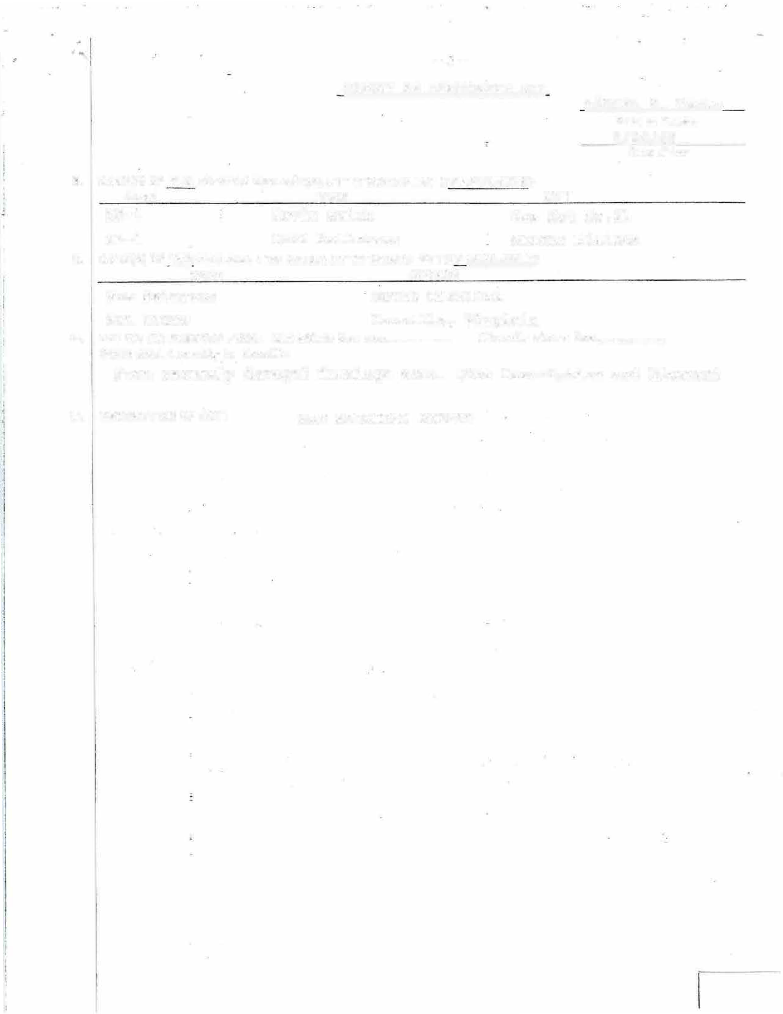From severely damaged fuselage area. (See Description and Diagram)

- DESCRIPTION OF ACT: SEE ATTACHED SHEETS

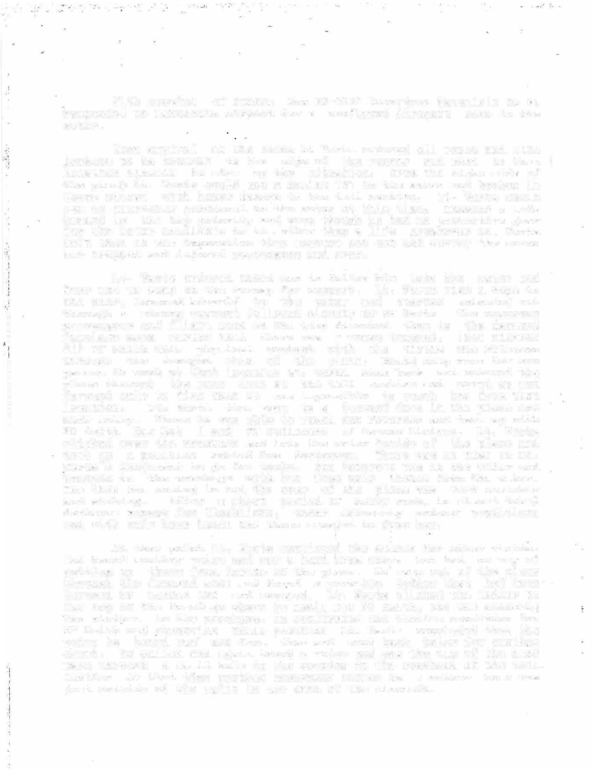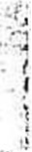With receipt of Queens Box 33-0037 Hazardous Materials Co #1 responded to LaGuardia Airport for a confirmed Aircraft down in the water.

Upon arrival at the scene Lt Warta ordered all ropes and life jackets to be brought to the edge of the runway and went to that location himself to size up the situation. From the right side of the plan� Lt. Warta could see a Boeing 737 in the water and broken in three pieces with heavy damage to the tail section. Lt. Warta could see no emergency personnel in the water at this time. Knowing a life hazard is the top priority and even though he had no protective gear for the �ater available to him other than a life preserver Lt. Warta felt that it was imperative that someone get out and survey the scene for trapped and injured passengers and crew.

Lt. Warta ordered three men to follow him into the water and four men to stay on the runway for support. Lt. Warta tied a rope to the pier, lowered himself to the water and started swimming out through a strong current followed closely by FF Smith. The numerous passengers and flight crew on the wing directed them to the damaged fuselage area saying that there was a woman trapped. (See Diagram #1) FF Smith made physical contact with the victim Sue Peterson through the damaged skin of the plane. Being only room for one person to work at that location Lt. Warta swam back and entered the plane through the rear door at the tail section and moved up and forward only to find that it was impossible to reach her from that location. Lt. Warta then swam to a forward door in the plane and made entry. There he was able to reach Sue Peterson and team up with FF Smith Haz Mat 1 and FF Feilmoser of Rescue Liaison. Lt. Warta climbed over the wreckage and into the water inside of the plane and took up a position behind Sue Perterson. There was no time in Lt. Warta''s judgement to go for tools. Sue Peterson was in the water and trapped in the wreckage with her face only inches from the water. The tide was coming in and the rear of the plane was very unstable and sinking. After a short period of heavy work, in almost total darkness except fer flashlight, under extremely arduous conditions and with only bear hands the three managed to free her.

At that point Lt. Warta continued the search for other victims and heard another voice and saw a hand £ram above but had no way of getting up there from inside of the plane. He swan out of the plane through the damaged side and found a portable ladder that had been lowered by Ladder 163 and secured. L�. Warta climbed the ladder to the top of the fuselage where he again met FF Smith, who was checking two victims in the wreckage. In confirming the victims condition for FF Smith and observing their position Lt. Warta concluded that t�e voice he heard was not from them and went back below for another check. He called and again heard a voice and saw the tip of the hand wave through a small hole in the opening in the overhead of the tail section. At that time another emergency worker in a rubber boat was just outside of the split in the skin of the aircraft.

. '
,

When requested by Lt. Warta he eased the nose of the boat through the opening. Lt. Warta climbed into the boat,· stood on the spray tube and eased up into a small confined area with his upper body. ( See Diagram #2} �·With a flashlight he could see a woman trapped in the wreckage. She reached down with her left hand took his hand and said, "Please get me out of here." Lt. Warta realized that there was no room to work in the very ponfined spa9e and nothing stable to stand: on, so he asked her name, to which she- replied Ann. Lt. Warta then told her that he was going for help and would be right back. He went to the rear section by boat and met members of Rescues
3 and 4 where he confirmed that they were in contact with and moving t6ward a trapp�d victim named Ann. Lt. Warta went to reassure Ann that help was on the way. The boat was then used to get a stokes stretcher to be used for Ann. Upon placing Ann in the stretcher it was handed back out by FF Murtha of Rescue 3 who also entered the boat and help transport Ann to the wing of the plane and awaiting rescue boats.

I
I
•j
l

I
j)

'.1
J
_j
By this time one body had already been recovered and FF Feilmoser was about to free the second body. Lt. Warta and the other emergency worker in the boat went back and positioned the boat to recover the second body when she was freed. They then transported her to the plane wing, help place her in a stokes stretcher and move her up on the wing to await a pickup boat.

By this time Lt. Warta had been operating for close to two hours and had been in and out of the water and the most damaged part of the aircraft many times. The entire aircraft and the sharp metal and debris all around.were constantly moving and shifting due to the many rescue boats and ·a helicopter operating in the area. At one point Lt. Warta had his leg tangled in some electrical wiring while in the water inside of the plane. The entire time Lt. Warta was experiencing a - terrible burning sensation of his body- caused by jet fuel and hydraulic fluid in the water coming in contact with his skin as he had no protective equipment on. He had been splashed with

hydraulic fluid in the eyes
�he eyes. Lt. Warta at exhaustion and cold.
and was experiencing severe burning of this time was feeling the effects of

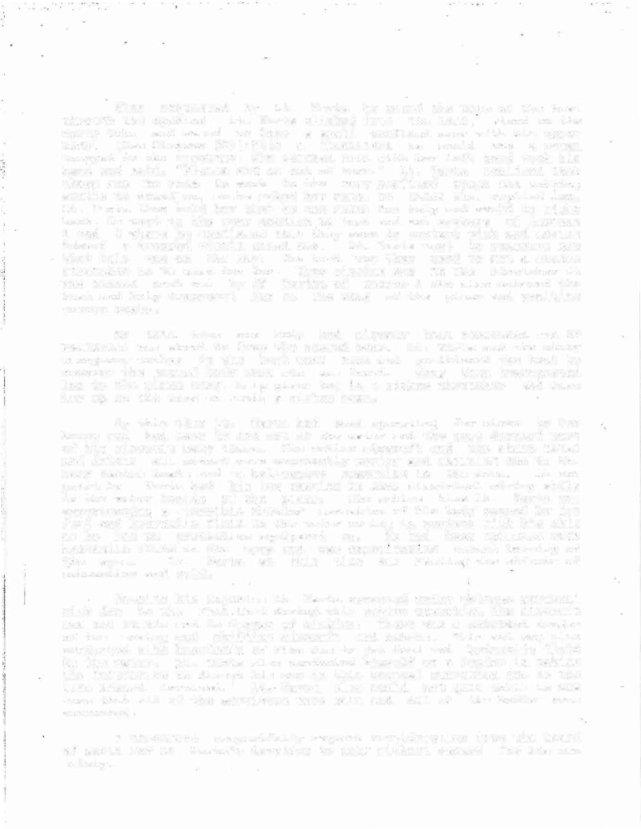
Despite his injuries Lt. Warta operated under extreme personal risk due to the fact,that during. this entire operati�n the aircraft was not stable and in danger of sinking. There was a constant danger of the moving and shifting aircraft and debris. This act was also conducted with knowledge of fire due to jet fuel and hydraulic fluid in the water. Lt. Warta also conducted himself as a leader in taking the initiative to direct his men in this unusual operation due to the life hazard involved.' Lt. Warta_ also would not quit until he was sure that all of the survivors were safe and All of the bodies were recovered.

I therefore respectfully request consideration from the board of merit for Lt. Warta's devotion to duty without regard for his own safety.

DIAGRAM# 1

Area where Sue Peterson was found

:- .::· :.�- . : --
���;:;�-s;;;;fI\.
·-

-�.�...
�-
::��;;�:: ... ,·.:p.
�=�-�� .:__�:,.:" ..

'· j

DIAGRAM #2

Area Of DOA's

Area where Ann
found

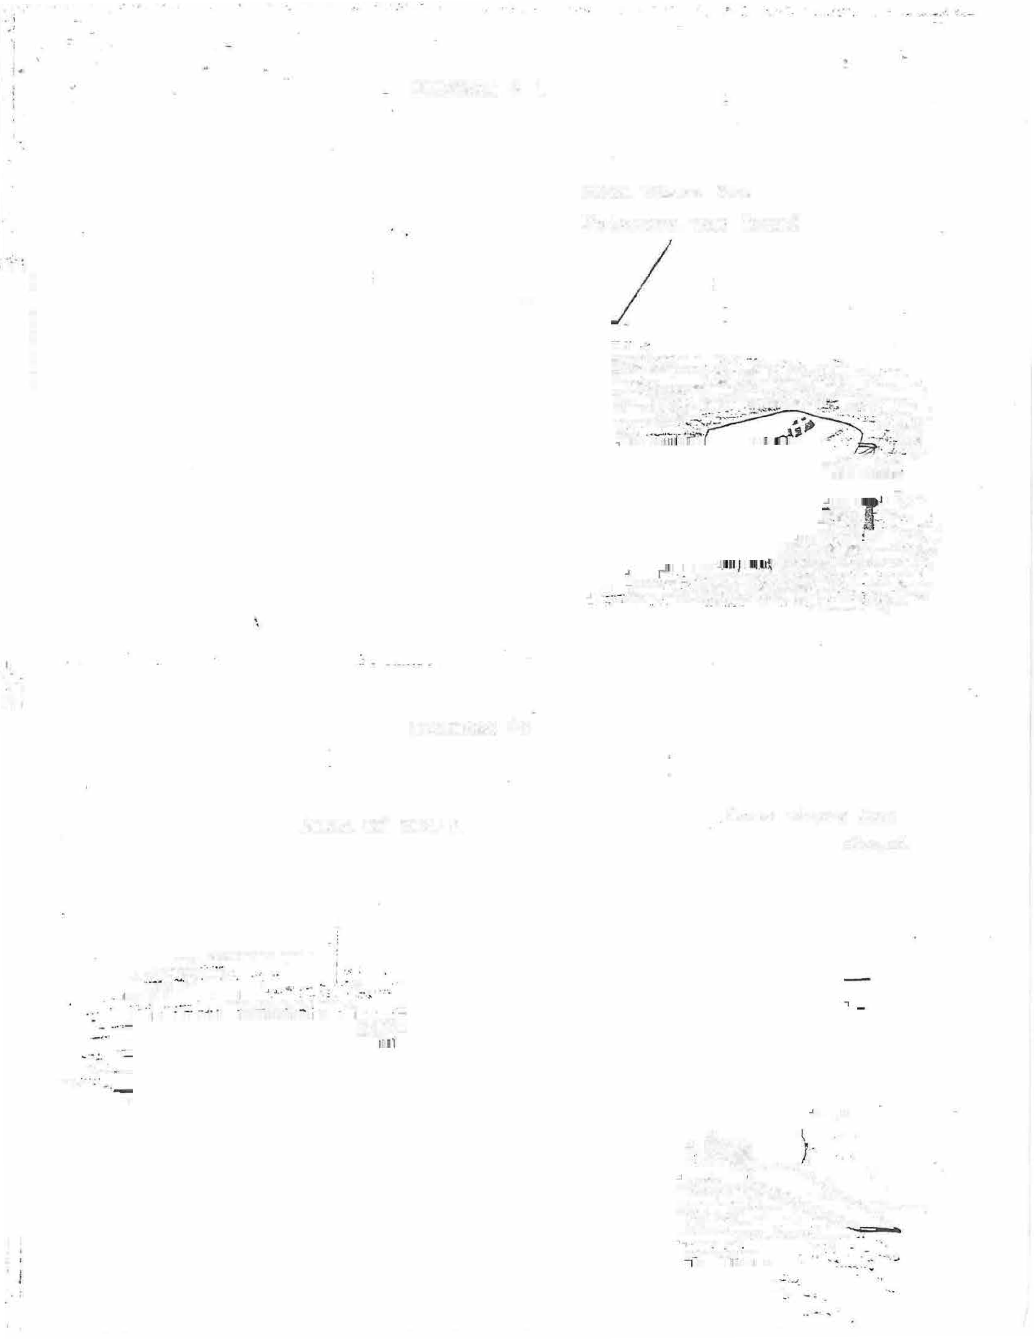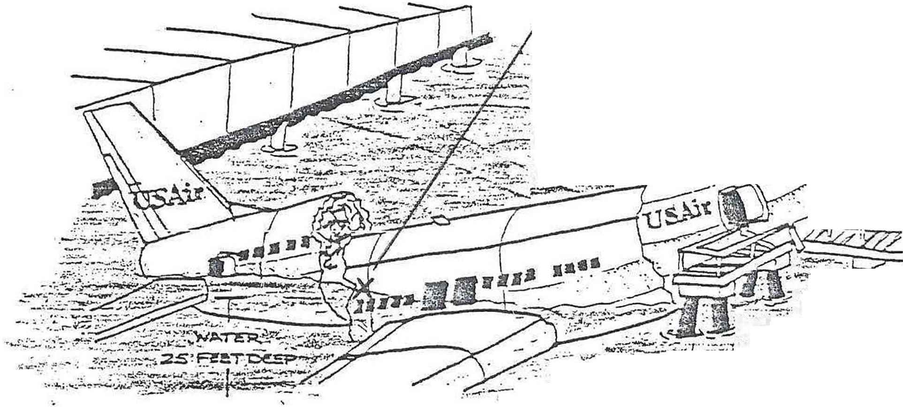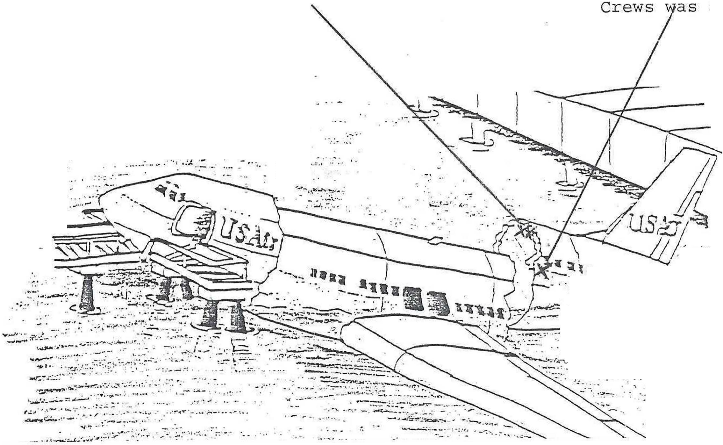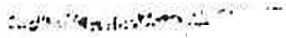

...

,:,

_, .. --
....��_'-:. ·-=�· -..�.·:. --·
_.. _ ,. _: :· ....:· 1" ··:·---� ...

: -�--:.. -... -.-:--·· .
-..;1·_,.

. . .
=��-

·�-�,.:-::-_:·�:-_�..-..:�:·�··:--·�---��:-· :· .. .
...___ _

BP-166 (•l/71) , REPORT OF MERITORIOUS ACT -? October 2, 1989
Date

- BOX 33-0037 BOROUGH_�Q�u_e_en (highest ala,m)
s_
DATE 9/20/89 TIME __2_3_2_4 _ _

- PERFORMED BY: FF-1 Kevin Smith Haz Mat Co. #1 Haz Mat Co. #1 Rank or Grade Nome Unit Assi _{g}ned De tailed
s.
- DID ANY OTHER MEMBER PARTICl?ATF. DIRECTLY IN THIS ACT?Lt. Albert Warta Haz Mat Co. #1
(If Yes) FF-1 Carl Feilrnoser Rescue Liaison Ronk Name Un it
ls Meritorious Act Report being forwarded for participating member?. Yes If not, how did
member panicipate?

- LOCATION OF MERITORIOUS ACT
:c.) If in building: Address

Height --._
Area _ Construccion

Occupancy Nurnbe� 0f !:!p!:!nrn�nt" in b1.1i!ding
Floor where ace cook place Room
b) If not in building: Give complete descriptive information so chat physical setting can be recreaced. An airplane down in the water at the end of the runway
_ at La Guardia Airport.

- PERSON (S) AIDED:
NAME Sue peterson Ann Crews
ADD'�ESS South Carolina Danville Virginia
AGE - SEX Female 25 Yrs Old Female 62 Yrs Old
RESCUE BREATHING No No
EXTERNAL CARDIAC MASSAGE No No
RESUSCITATOR APPLIED No No
HOSPIT AL !ZED Yes Yes
NAME OF HOSPITAL Jamaica Hospital Jamaica Hospital
DIAGNOSIS Lacerations Broken Wrist
LENGTH OF HOS PITALIZATION 9 Days I 1 Day
- MEMBER PERFORMING ACT: Did he receive any emergency treatment? Y-es-------------- Specify Laceration of face and exposure to jet fuel on the body'
Yes
Was medical leave gr anted?
Laceration
and exposure
Diagnosis
- WHAT SPECIFIC JOB WAS MEMBER PERFORMING AT TIME OF RESCUE?--Ex-t-ri-c-at-io-n �--
WAS MEMBER ALONE?_ No ( If not, indicate number of Fire Department personnel in im mediate area, and describe their positions in# 11,
WAS A MASK WORN BY MEMBER DURING RESCUE? · NA_____________ __
WAS CHARGED HOSELINE IN POSITION TO PROTECT MEMBER MAKING RESCUE? --N-A -----------
_

HOW WAS VICTIM REMOVED FROM PREMISES? Carried Dragged
Assisced Y_es _

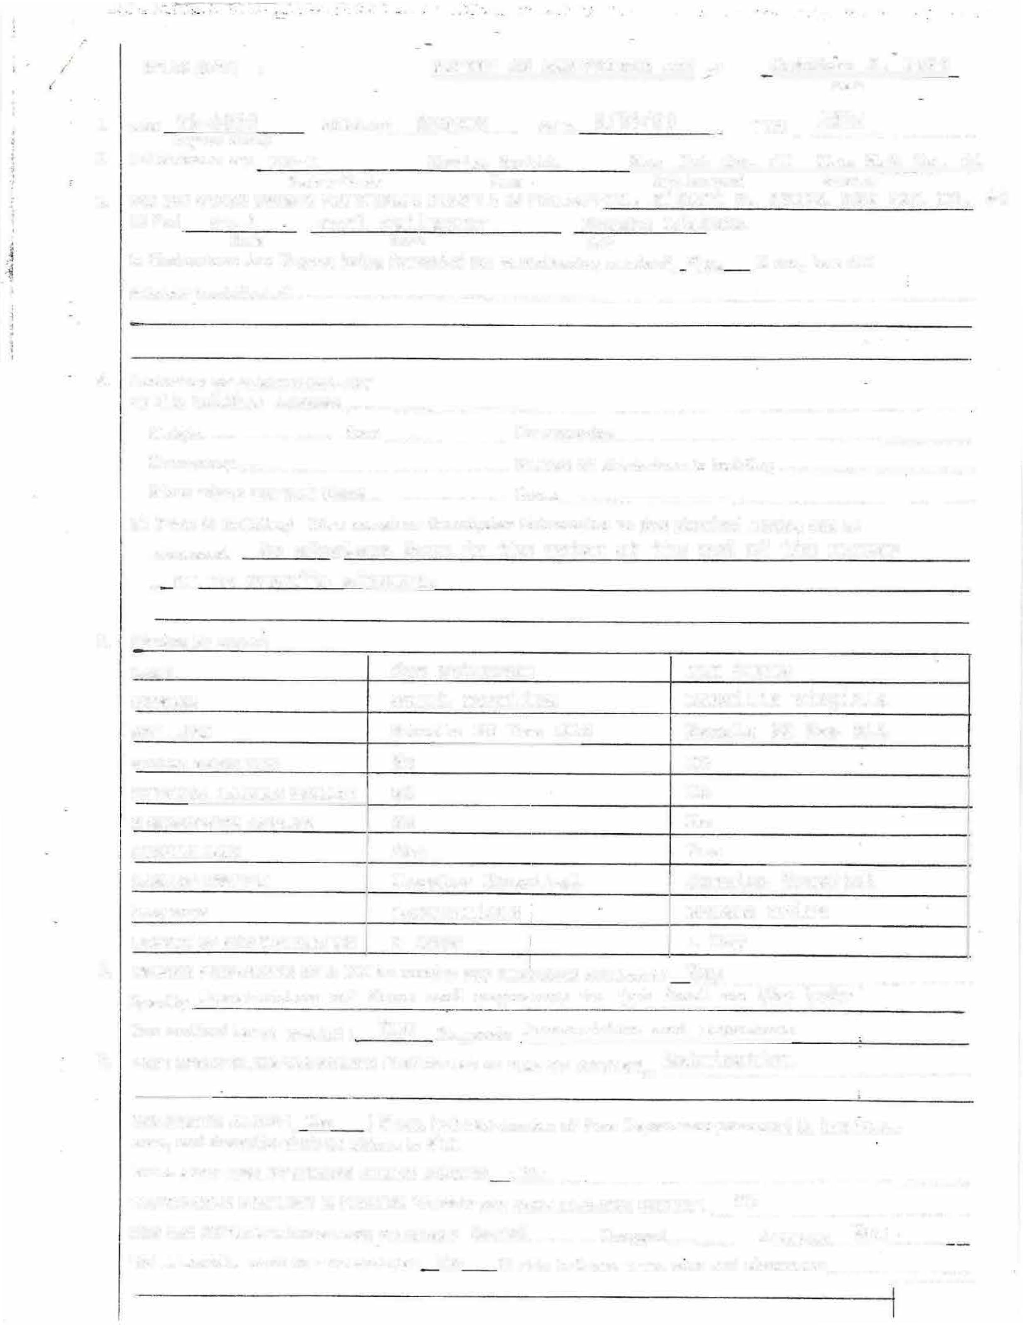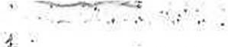WAS A LADDER USED IN THIS RESCUE? No If yes, indicate cvpe, size and placement �_-_-_-_-_-_-_

I

- '.: -
REPORT OF MERITORIOUS ACT

- NAME (S) OF TWO MEMBERS WHO ACTUALLY WITN!:SSED ACT (IF AVAILABLE)
RANK NAME UNIT

Kevin Smith
Nome of Member
9/20/89
Dote of Act

Lieut. FF-1
Alberts. Warta Carl Feilmoser
Batt. 46 Rescue Liaison

- NAME (S) OF TWO C IVILIANS WHO ACTUALLY WITNESSED ACT ( IF AVAILABLE)
NAME ADDRESS
Sue Peterson South Carolina
Ann Crews Danville Virginia

- WAS VICTIM REMOVED FROM: Immediate fire area Orh ,., ,irea ( specify in derail):
Direccly above fire

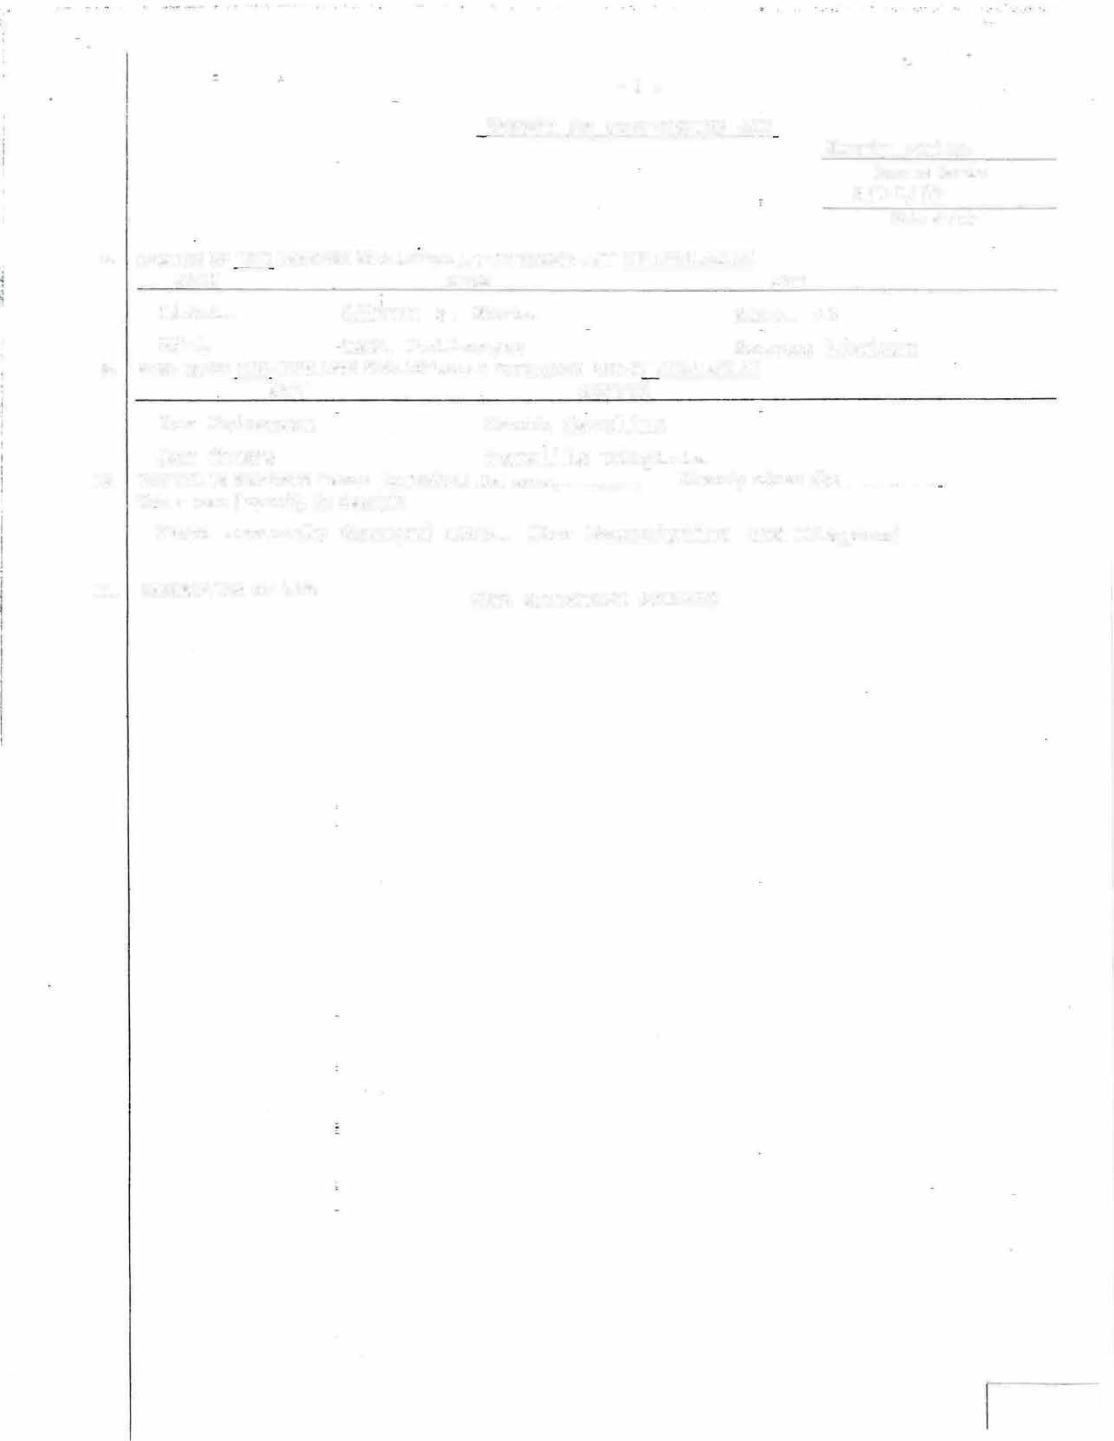From severely damaged area. (See Description and Diagram)

l l. DESCRIPTION OF ACT: SEE ATTACHED SHEETS

With receipt of Queens Box 33-0037 Hazardous Materials Go, #1 responded to LaGuardia Airport for a confirmed Aircraft down in the water.
Upon arrivar, all members reported to the edge of the runway with ropes and life jackets as ordered. From the right side of the plane FF. Smith could see that a Boeing 737 was in the water and broken in three pieces with heavy damage to the tail section. FF. Smith volunteered to accompany Lt. Warta into the water, even though he knew he had no protective gear available to him other than a life preserver. He lowered himself by rope into the water and started swimming to the plane, against a strong current. The numerous passengers and flight crew on the wing directed him to a damaged fuselage area saying there was a woman trapped, (See Diagram).
FF. Smith swam to the section of the fuselage where the tail had separated from the main section, where he saw the trapped woman, When he reached the woman, FF. Smith noticed that she was still in her seat and the seat was folded forward and twisted toward the isle of the plane. FF. Smith could only see the right rear side of the woman from her neck to her hips. Her right arm was the only part of her that he could see that was not trapped. The water was up to the level of the seat so that the lower half of her body was under water. He was not able to see her head but was sure her face was very close to the water. He grabbed her arm and asked if she could hear him. She yelled for him to get her out. He asked he� her name to which she responded, Sue. He told her to stay calm, that we would get her out, FF. Smith was able to get a foot hold and boost himself up onto the side of the fuselage.
At this point he was able to see a lot of debris such as seats, overhead luggage racks, luggage, and parts of the planes structure pinning her to the seat. Maintaining this position-was very difficult due the oil and water covering the planes surface and the rocking of the fuselage from boat wakes and turbulence of helicopters now in the area�

FF. Smith was able to get his 1 other foot
up and climb

into the attain a
plane through the sharp jagged split position on the victims right side.
and debris and

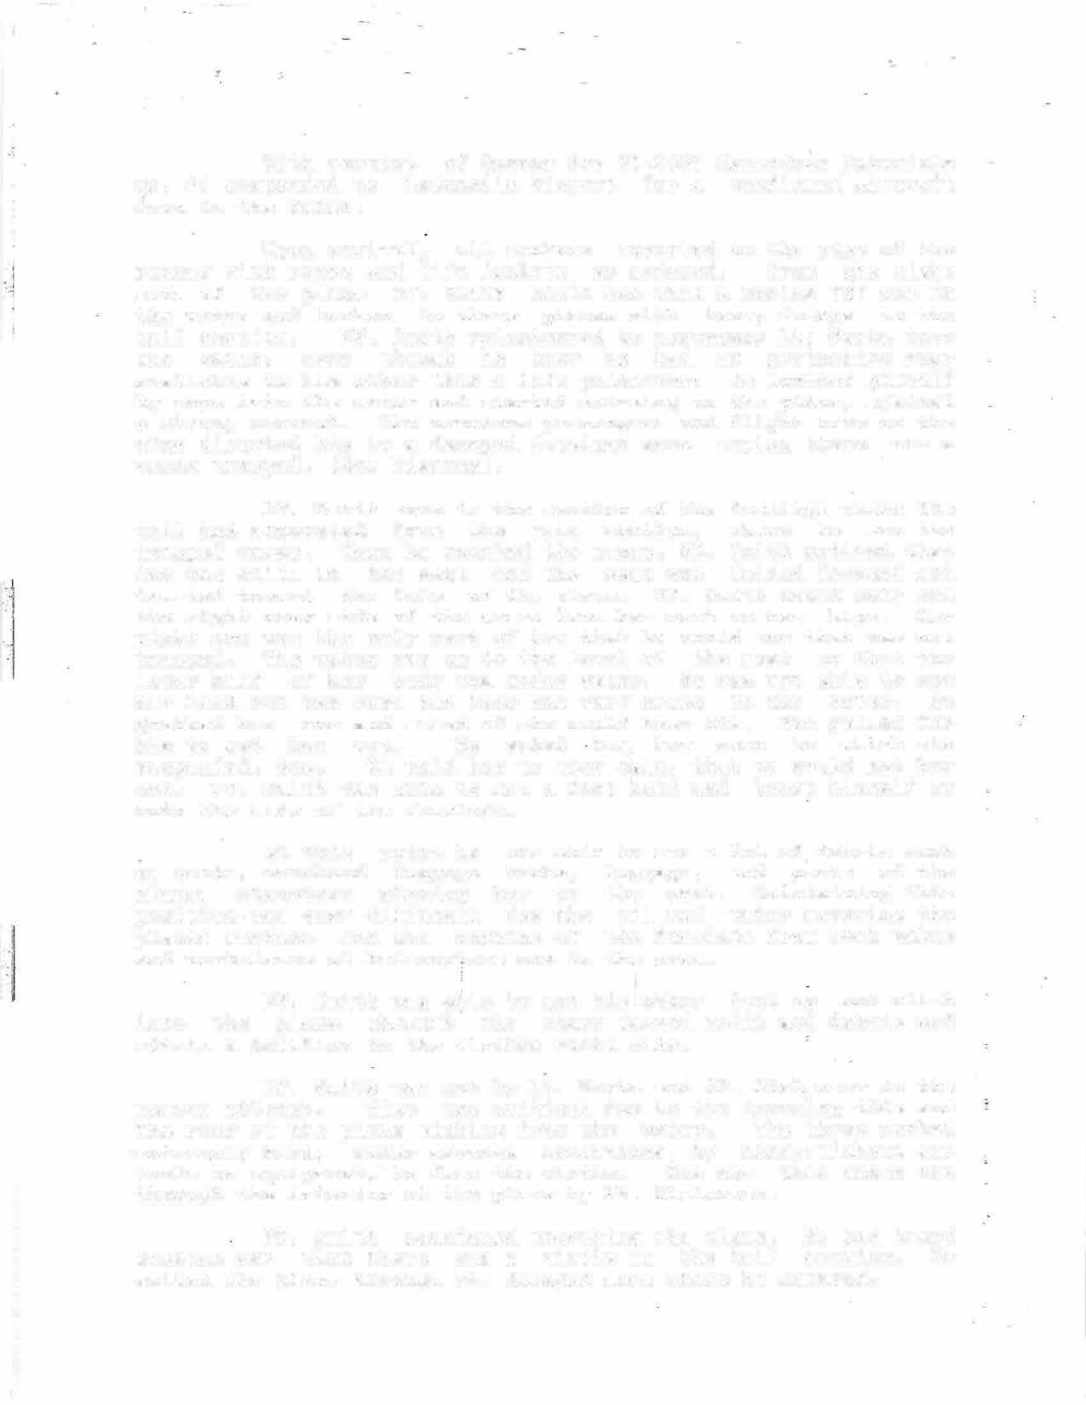FF. Smith was met by Lt. Warta and FF, Fiel�oser in the rescue attempt. Time was critical due to the incoming tide and the rear of the plane sinking into the water. The three worked
-extre�ely hard, under adverse conditions, by hand,,without any tools or equipment, -to free the victim. She was then taken out through the interior of the plane by FF. Fielmoser.
FF. Smith continued searching the plane, He had heard someone say that there was a victim in the tail section. He exited the plane through the damaged area where he entered,

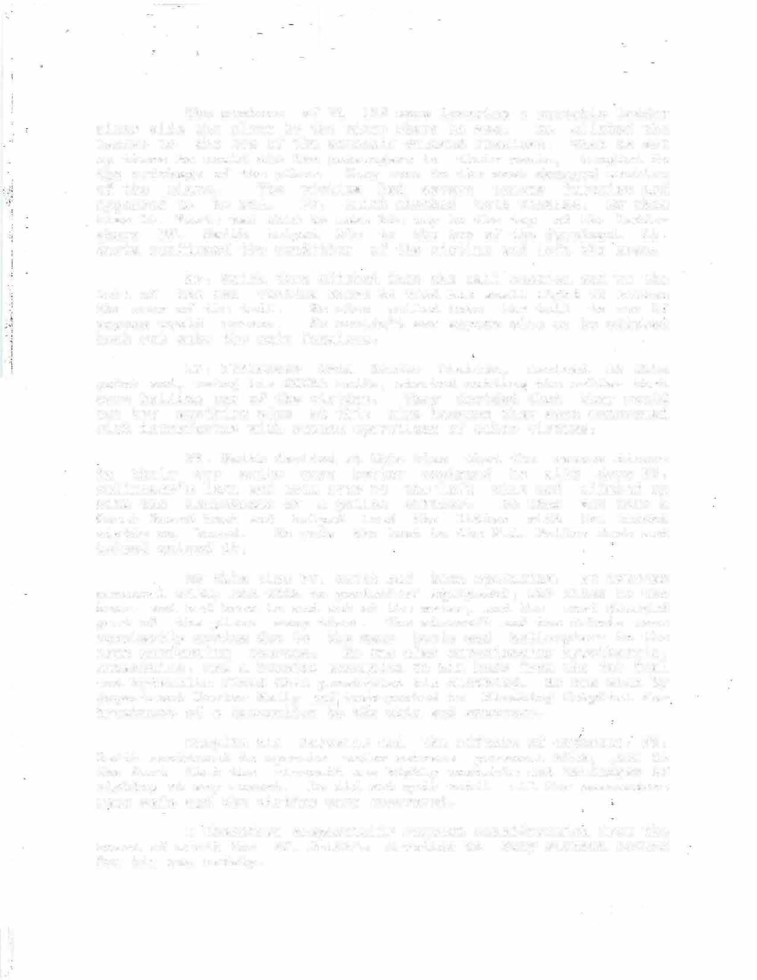The members of TL 163 were lowering a portable ladder along side the plane to the water where he was. He climbed the ladder to the top of the severely damaged fuselage, When he got up there he could see two passengers in their seats, tangled in the wr�ckage of the pYane. They were in the most damaged section of the plane. The victims had severe trauma injuries and appeared to be DOA. FF. Smith checked both victims. By this time Lt. Warta was able to make his way to the top of the ladder where FF, Smith helped him to the top of the fuselag�. Lt. Warta confirmed the condition of the victims and left the area.

FF. Smith then climbed into the tail section and·to the left of the two victims where he used his small light to search the rear of the tail. He also yelled into the tail to see if anyone would answer. He couldn't see anyone else so he climbed back out onto the main fuselage.

FF. Feilmoser from Rescue Liaison, arrived at this point and, using his SCUBA knife, started cutting the cables that were holding one of the victims. They decided that they would not try anything else at this time because they were concerned with interfering with rescue operations of other victims.

FF. Smith decided at this time that the rescue divers in their dry suits were better equipped he slid down FF. Feilmoser's legs and swam over to the·left wing and climbed up with the assistance of a police officer. He then got into a Coast Guard boat and helped load the litter with the second victim on board. He rode the boat to the P.A. Police dock and helped unload it.

By this time FF. Smith had been operating, at extreme personal risk, and with no protective equipment, for close to two hours and had been in and out of the water, and the most damaged part of the plane many times. The aircraft and the debris were constantly moving due to the many boats and helicopters in the area performing rescues. He was also experiencing hypothermia, exhaustion, and a burning sensation to his body from the jet fuel and hydraulic fluid that penetr�ted his clothing. He was seen by Department Doctor Kelly and transported to Flushing Hospital for treatment of a laceration to th'e chin and exposure.

Despite hi� injuries and the effects of exposure, FF. Smith continued to operate under extreme personal risk, ,due to the fact that the aircraft was highly unstable and in=danger of sinking at any moment. He did not quit until all the passengers were safe and the victims were recovered.

I therefore respectfully request consideratio� from the board of merit for FF. Smith's devotion to duty without regard for his own safety.

.1
,j l

..

Area where two DOA's were located

\
\

Area where operat·ions _,c;>n top of fuselagE were carried

Area where 1st vict·im was trapped Area submerged in picture.
�l. • _;

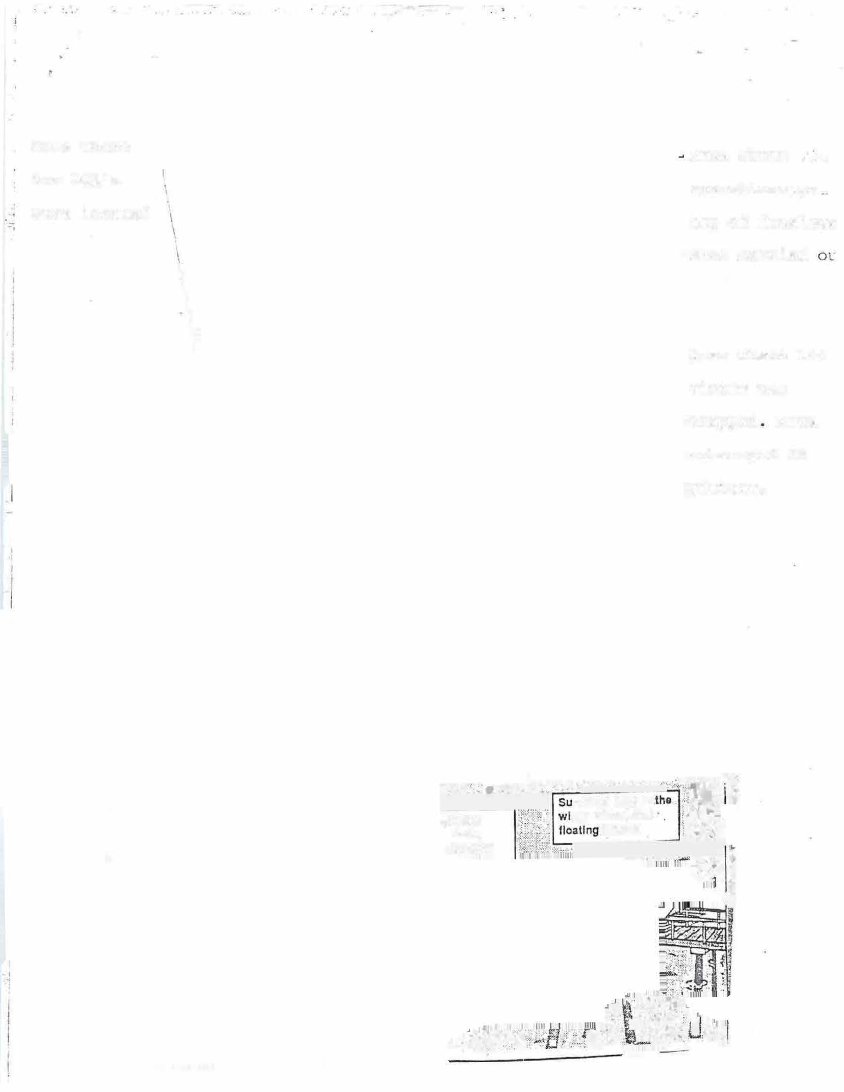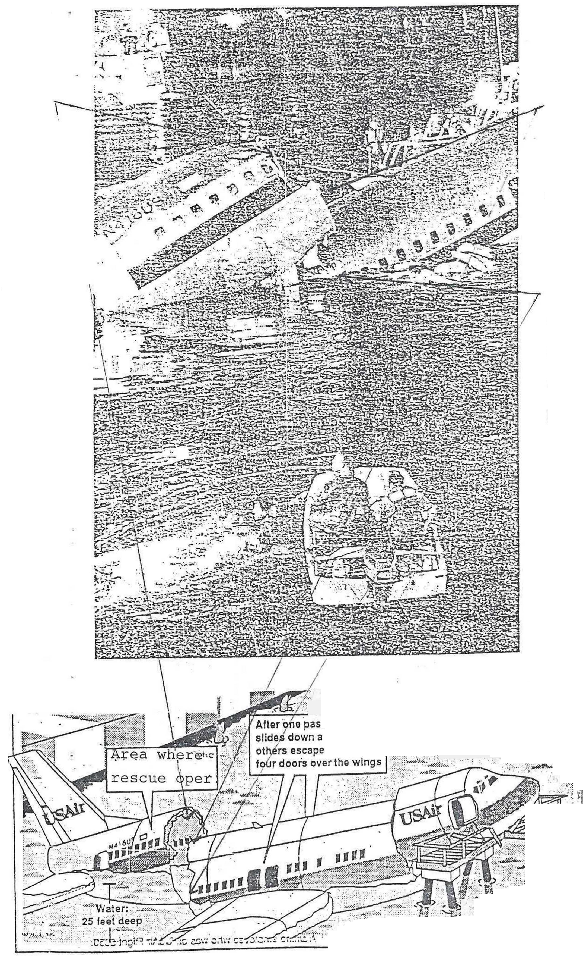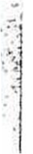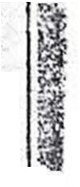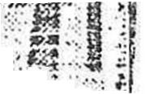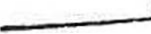

:::··--�:-=··. , . ❖..-:�,.. ��� •

:...:· .. j1'
<.,.,,�·�i1 �
ii.

ENGINE -CO. 250-September 2; 1989
Box 75-2471, 0433 hours
789 Westminister Road, Brooklyn Capt. Peter Hayden, L. 147
FF. John Castagna
FF. John· LoGrasso
FF. Robert Fulco
FF. Michael Quinn
FF. Scott Stromer
UNIT CITATIONS (continued)
ENGINE CO. 307-September 20, 1989
Box 33-0037, 2322 hours LaGuardia Airport, Queens Lt. Louis Monteleone
FF. Charles Hoffman
FF. Kevin Kelly
FF. Christopher Huss
FF. Michael DiGiorgio, L. 154
LADDER CO. 154-September 20, 1989
RESCUE co. 4-Septernber 20, 1989
Box 33-0037, 2322 hours LaGuardia Airport, Queens Lt. Thomas A. Williams
FF. Michael Milner
FF. Robert Leone
FF. Peter Cozeolino
FF. Ralph Williams

2.1

LADDER CO. 157-September 2, 1989
Box 33-0037, 2322 hours
FF. Richard Gardner 1

Box 75-2471, 0433 hours
789 Westminister Road, Brooklyn Lt. Jeremiah P. Collins
FF. Gareth Nielsen
LaGuardia Airport, Queens Lt. Daniel F. Buckheit
FF. Albert Johanson
FF. James F. Brooks
RESCUE CO. 5-September 20, 1989
Box 99-0037, 2330 hours
LaGuardia Airport, Queens

FF. William Hartman
FF. Joseph Jardin
Capt. Charles J. Driscoll
ENI

FF. Peter Tracy
FF. Dennis Barnes
FF. Van D. Williams
FF. Robert S. Maxwell
FF. Michael P. Barone
FF. Robert Brown
Box
43£

FF. Robert Limperio
FF. Robert J. Winterfeldt, E. 292
FF. Peter Brunaes
LAf

ENGINE CO. 9-September 3, 1989
Box 22-195, 0101 hours
92 The Bowery, Manhattan Capt. William P. Blaich, Div. 1
FF. Peter Bosco
FF. Marie K. Bell
FF. George A. Braadt
FF. Anthony E. Delillo, Jr.
FF. Michael Price
ENGINE CO. 96-September 5, 1989
Box 2638, 1515 hours
1893 Lacombe Avenue, Bronx Capt. Thomas M. Loughran
FF. Eugene Ashe
FF. Robert W. Englehart
FF. Richard M. Kirschner
FF. Patrick J. Woods
FF. Robert R. Reynolds
RESCUE CO. 2-September 20, 1989
Box 33-0037, 2330 hours LaGuardia Airport, Queens Lt. John W. Norman, B. 57
FF. Lee lelpi
FF. Elbert Washington
FF. Bruce Howard
FF. Michael Pena
FF. Denis Murphy
LADDER CO. 117-September 20, 1989
Box 33-0037, 2322 hours LaGuardia Airport, Queens Lt. William M. Donald
FF. Michael Cain
FF. Miguel Berrios
FF. John J. Messina
FF. Michael Mahan
FF. Robert M. Stark , E. 312
LADDER CO. 163-September 20, 1989
Box 99-0037, 2322 hours LaGuardia Airport, Queens
Capt. Richard S. Rewkowski, Div. 14
FF. George Carlin
FF. John J. Kearney (4)
Pr. James C. Quinn
FF. Stephan J. Dominick, E. 325
FF. Chris A. Messana, E. 325
RESCUE CO. 3-September 20, 1989
Box 99-0037, 2322 hours LaGuardia Airport, Queens Lt . Peter B. Lund
FF. Gerard Murtha
FF. Christopher Blackwell
FF. Steven O'Donnell
FF. Jack Bugliarello
FF. Edmund O'Mahoney, L. 45
FF. John E. Foster
FF. Fred J. Claudio, L. 8
HAZ-MAT CO. - tember 20, 1989
Box - , 324 hours LaGuardia Airport, Queens · Lt. Albert S. Warta
FF. Kevin Smith
FF. Vincent J. Doherty
FF. Carl Schramm
FF. Robert J. Ingram
FF. Natale J. Russo
FF. Thomas P. Daly
FF. Richard Keller
ENGINE CO. 156-November 2, 1989
Box 75-378, 0735 hours
36 Britton Street, Staten Island Capt. William F. Gates
FF. John Driscoll
FF. George Hecker
FF. Francis Wicinski
FF. Martin Merrick
FF. Conrad Degen, L. 80
80)
22�
LAI
Bo>
54:
EN
Bo:
54!
EN
Bo
54
LA
Bo
54
I.ft. Be 73
I.ft Be 2:
H
Be Ht
M
u

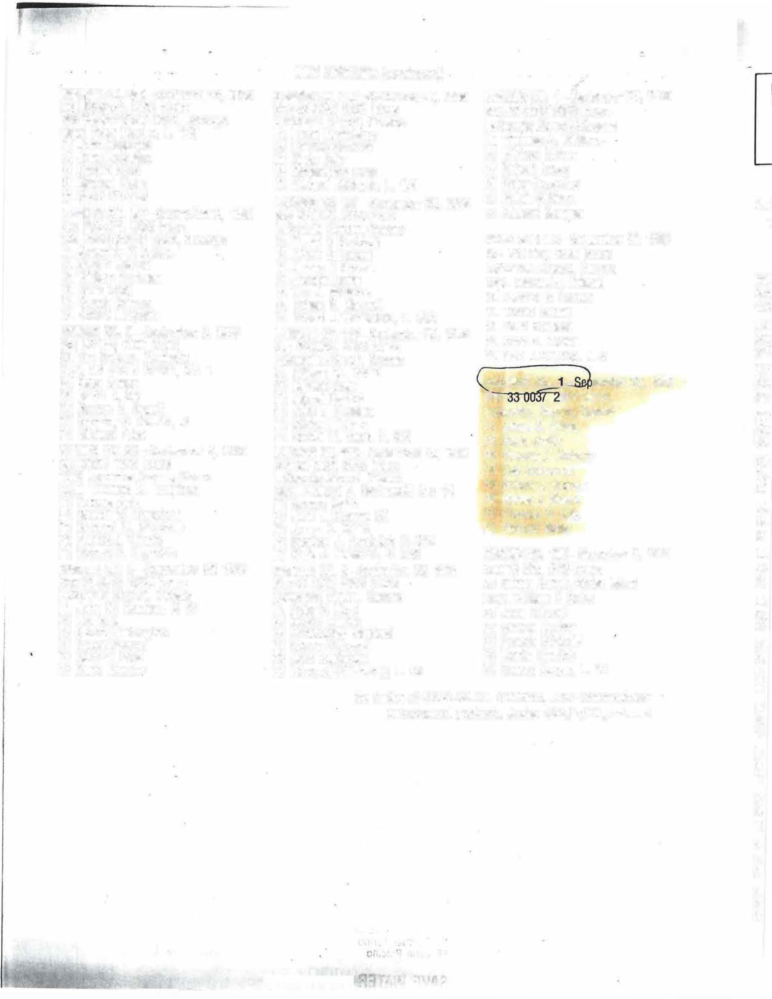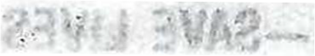By Order of CARLOS M. RIVERA, Fire Commissioner
JOSEPH M: DEMEO, Acting Chief of Department Be 11
Li Br 1,
R B 1 (
R B 2
L B 6

