Confined Space Hydrogen Sulfide Incident
In Manhole
April 14, 1987
On the arrival of Haz-Mat 1 at this incident the following situation was found. A sewage valve 50'below ground was opened by Environmental Protection Agency (EPA)workers to remove raw sewage from a damaged section of pipe. After the valve was opened the EPA monitoring equipment registered extremely dangerous levels of HYDROGEN SULPHIDE(h2S) in the manhole and surrounding area. At which time the EPA workers abandoned the work site, leaving the valve in the open position with a continuous increasing flow of raw sewage and H2S into the manhole and surrounding area.
Research conducted by the Haz-Mat team reinforced EPA knowledge of the EXTREMELY toxic and FLAMMABLE characteristics of H2S.In addition to having a upper explosive limit of 46%, and a lower limit of 4.3%,Flash point 76% ,Specific Gravity 1.54 it is also a severe eye, skin, and mucous membrane irritant, poison gas and neurotoxin and at concentrations of 300 ppm it is IMMEDIATE DANGEROUS TO LIFE AND HEALTH.
A primary survey was conducted by FF. Meisenheimer and FF Hay, Haz­
Mat 1 entry team for this tour and confirmed readings well over l00 ppm.
of H2S above the manhole Due to the Specific Gravity of H2S we knew that the concentrations would: be much higher further the down the manhole.
At this time the EPA, foreman notified Dep. Chief Hatton 10 Div. and Batt Chief Birello 31 Batt that if the VALVE is ¹not closed in 15 min. the sewage level would r se above it, making it almost impossible to close the valve. This would continue to give off increasingly high concentrations of H2S to the surrounding area posing a severe Respiratory and Fire hazard to the workers and area residents. (When water is mixed with H2S
Sulfuric Acid is formed)
Due to safety factors (descending 30" manhole with 9 in. rungs) rec­ commended Level A" fully encapsulated protection had to be waived for a lower but more maneuverable level of protection. Fully aware of the wide flammable range of H2S , but unable to monitor the flammable levels due to time constraints etc. FF Meisenheimer and FF Hay knew that they would have little or no protection against a Flash fire and exposure to TOXIC H2S. Secured to Life Saving ropes FF Meisenheimer and FF Hay started descending the manhole.

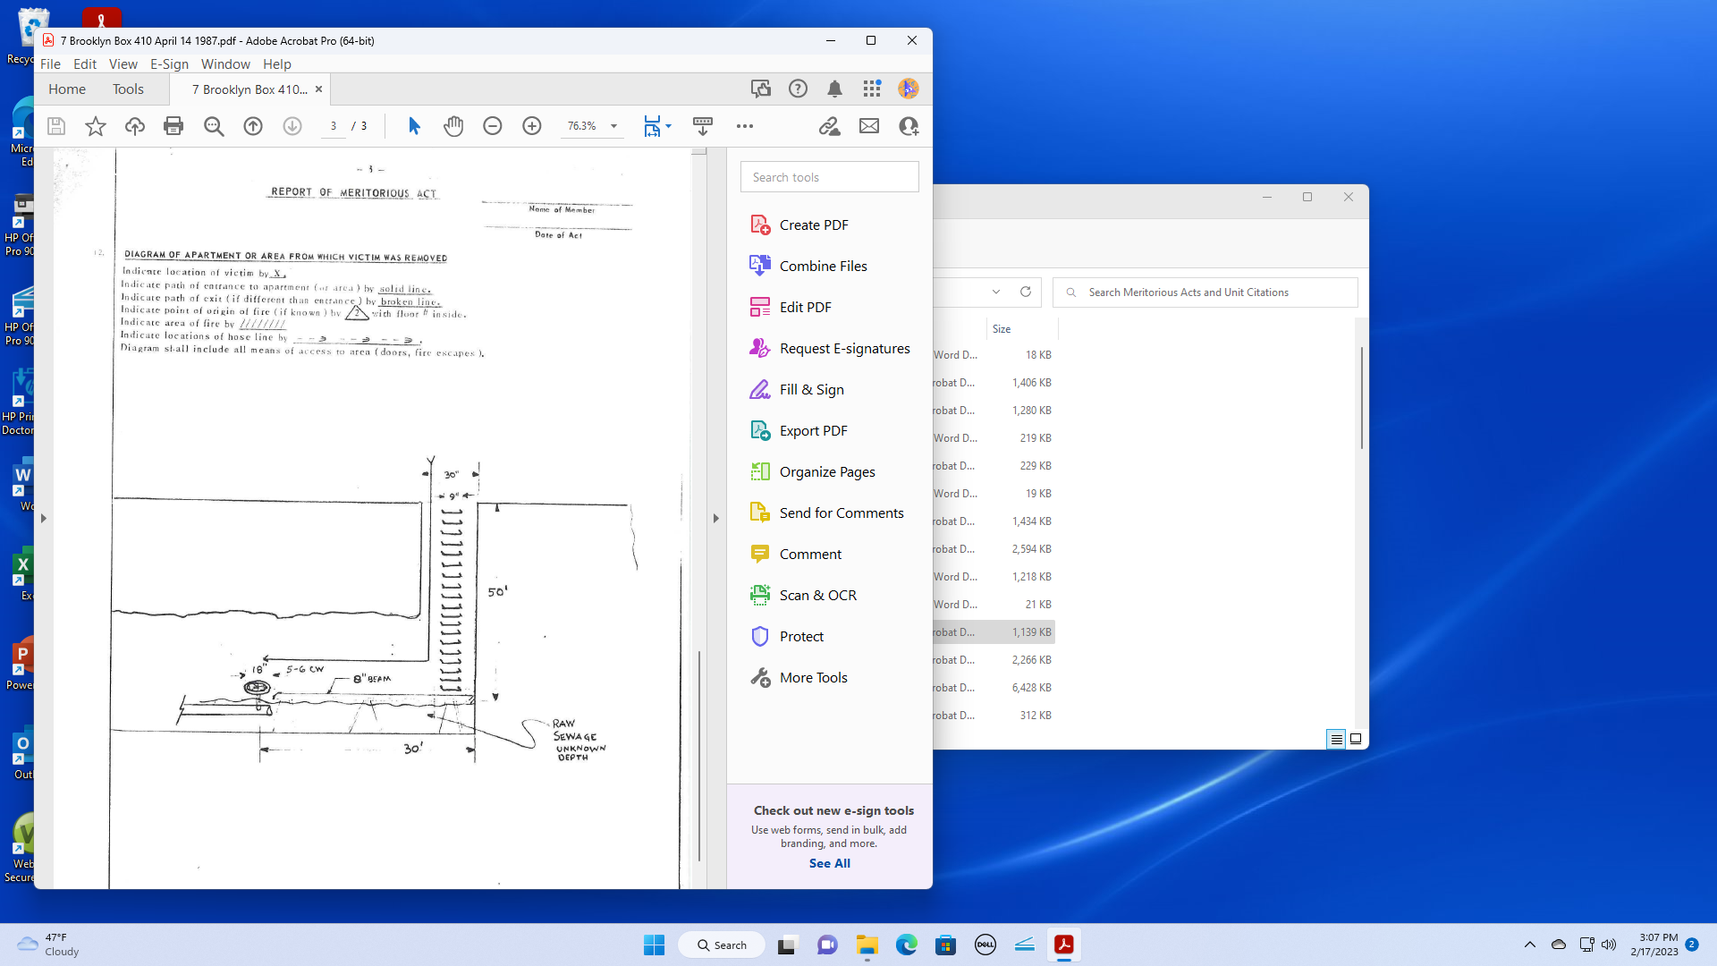
After descending 50' to bottom of manhole, both firefighters had to traverse a 8 inch wide plank for 30 ft to reach the valve. At this time the unknown depth of the raw sewerage was just below the 8 inch plank. Due to the fact that the valve opening was fully submerged in raw sewerage both firefighters had to clean out the gate first before fully closing the valve. After successfully closing the valve the firefighters then left the highly toxic and flammable area.

