Larry Singletary

Friday, January 5, 2018

Good morning to All.

It is my honor today to talk about a man who I have known since 1984. If anyone is counting; that’s 34 years. I know most people don’t like long drawn-out speeches; so, I promise to keep this short and sweet.

Larry was born back in 1945 at the end of World War II, he is 10 years my senior. Larry was a veteran serving in the U.S. Air Force before he became a Fireman. He was appointed to the FDNY on September 24, 1977, at the age of 32. Larry started his career in the South Bronx in Engine 60 and on Castle Hill in Ladder 47. Larry also spent time in Ladder 130 in Queens and in Engine 304 in Brooklyn. It is when Larry came to Haz-Mat 1 (a city-wide unit) that I first met him.

From the start, Larry was a no-nonsense type of guy. He was dedicated to his chosen profession. Larry was calm under pressure, didn’t overact and was someone you could trust in a fire or emergency. He was a hard worker who shied away from the limelight, preferred to do his job quietly and walk away at the end of the day. He never complained about work and pitched in whenever someone needed help.

No Fireman’s Memorial would be complete without at least one or two firehouse stories:

The Firehouse Pictures

In the beginning back in 84, Haz-Mat was a new technology that the FDNY was forced into accepting. The Department was very steeped in tradition; some said: “THE JOB IS FIRE: it was 150 years of tradition unimpeded by progress”. In any event Haz-Mat was a New Concept. In the beginning it got a lot of publicity. We made the cover of Penthouse, National Geographic World, and other magazines. So, there were times that we were being photographed by different magazines for articles in those magazines & newspapers. On one occasion Larry and I were selected to do a photo shoot because the photographer said “we were the most photogenic people working at the time. The shot was of the both of us in front of an overturned Gasoline Tanker. As part of the shot we were to stand in front of the tanker in our jumpsuits and partially dressed in chemical protective clothing. As part of the backdrop the tanker was going to be lit on fire. The guys we were working with that day were going to assist in keeping the fire going for the shoot. They more than happily kept feeding the fire (payback time) to the point that the hairs on the backs on Larry’s and my neck were singed from the heat. But Larry and I didn’t move, it was one of the best pictures ever taken.

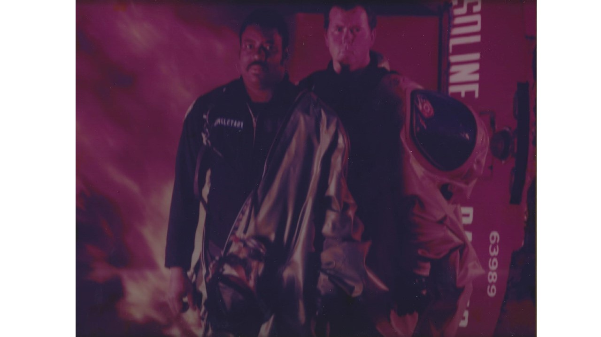

As I had mentioned earlier Larry was a dedicated fireman and anyone who heard stories of Firehouse life knows that you are with these people for a 1/3 of your life during your career; in many respects they are your 2nd family. The firehouse was often referred to as our 2nd home. Everyone pitches in, keeps it clean, and does what we call “Committee Work”. Larry was no slouch and no job was beneath him, he did whatever had to be done. As a senior guy, he could have just let the junior guys do the work, not Larry he pitched right in. He was quick to get in the sink after meals, no job was too menial for Larry. He did, however, have one flaw, he didn’t cook. He would help with the prep, he would do clean-up, but wouldn’t cook. One day one of the members decided to challenge him about not cooking; it was their mistake. Larry chased him all around the firehouse, which was the last time anyone brought up anything about Larry cooking.

You’re not going to remember anything I talked about today. Just keep this in mind when you think of Larry:

He was a Son, A brother to those of us who worked with him, A Father to Erick & Lance, A Grandfather to Erick’s children, he was a friend to all who knew him, especially Jolene.

But most of all he was:

A GREAT HUMAN BEING

THANK YOU