- 9/11/2001 MANHATTAN BOX-300
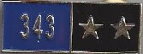
  - FF Jeff Borkowski, FF Phil McArdle, FF Armen Koroghlin, FF Bob Hunter, FF Anthony Castagna

- 9/20/1989 QUEENS BOX-33-0037
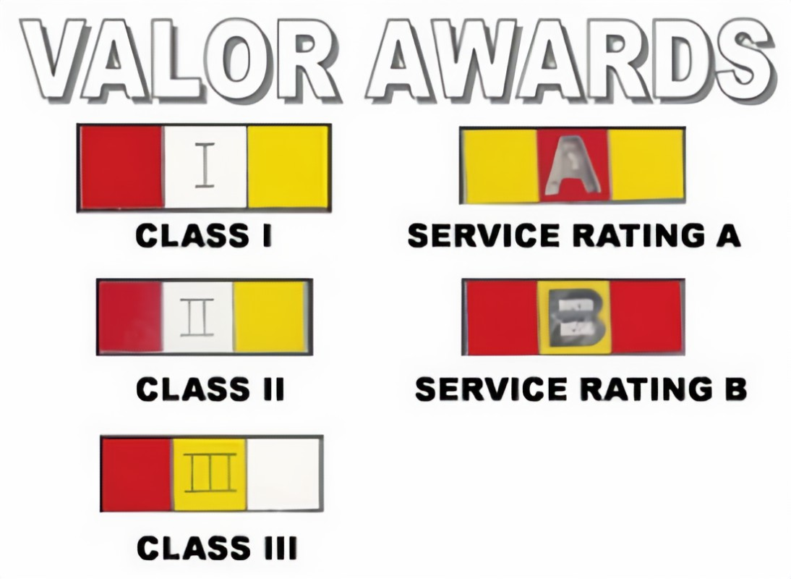
  - Lt. Al Warta (Wesley Williams Medal) & FF Kevin Smith (Fiorello LaGuardia Medal

- 11/19/1988 Manhattan BOX – 0554
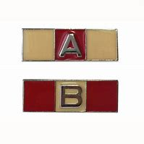
- FF Bob Ingram & FF Phil McArdle

- 4/14/1987 BROOKLYN BOX-410
  - FF Ray Meisenheimer & FF James Hay

- 4/15/1992 QUEENS BOX - 4593
  - FF James Hay

- 7/4/1990 BRONX BOX - 4184
  - FF Phil McArdle

- 5/20/1991 BRONX BOX – 33 - 4146
  - FF Phil McArdle

- 8/14/1988 Nassau Co. BOX – 0000
  - Lt. Al Warta

- 9/13/1989 QUEENS BOX – 2935
  - FF Kevin Smith

- 2/20/1988 QUEENS BOX – 3143
  - FF Mike Kaner

