The Hazardous Materials Technician Engine Company

Captain John Flynn, Division 3

“Increased Role and Mission”

Hazardous Materials emergency response – perceived at times in the past as somewhat foreign and extraneous to the role of the New York City Fire Department - has in recent years become a significant challenge and opportunity for the Department. The growth in the need for companies trained to deal with haz mat releases has been explosive and exponential. This growth is tied to a proliferation of new chemical substances and the ever-increasing threat of chemical, biological and radiation-based terrorist activity within our borders.

In an effort to keep pace with these challenges the Department has established a unique company-based hierarchy of response, largely accomplished via an ever-growing Haz Mat Group. From it beginning in September of 1984 with one company, four officers and 35 members, the Haz-Mat Group now includes sixty-nine fire companies with 1,600 members and 20 medical units with over 150 members. One of the more recent additions to this special group of companies is the Hazardous Materials Technician Engine Company herein referred to as a “Tech Engine.” Similar in training and assigned equipment as the seven Squads and Rescue 5, these eleven companies are known as Hazardous Materials Technician Units, or HMTU’s”. Basic operating protocols for all HMTU’s in the FDNY are provided in Fire Tactics and Procedures: Hazardous Materials 8. This article is intended to more fully describe the nature and characteristics of these unique Companies.

“What is a “Tech Engine” and what is it’s’ mission”?

Three Tech Engines presently exist on the Department – E-44 in Manhattan, E-165 in Staten Island and E-274 in Brooklyn and were placed in service May 1, 2004. All members of these companies have received training consisting of 80 hours of intensive study aimed at bringing each and every member to the Technician 2 level of Hazardous Materials response. The study material is uniquely “Department specific” – that is to say, it is based upon the challenges faced by the New York City Fire Department as observed over many years of dedicated response. We are fortunate to possess a history of Haz Mat emergency response that is unmatched virtually anywhere in the word. Funding for all of the training, equipment, apparatus and training backfill costs have primarily come from Federal Department of Homeland Security Grants applied for through the commissioners’ office of Intergovernmental Affairs.

NOTE: A fourth (4th) engine company, E-250 is scheduled to begin training to this level in February of 2005.

The Primary purpose of the Tech Engine/HMTU is as stated in Hazardous Materials 8:
- Augment and Support Hazardous Materials Company 1, (HMC 1)
- Provide Haz-Mat response coverage in their assigned Haz-Mat response area when HMC1 is not available.
- Respond with other units in the Haz-Mat Group to large scale Haz-Mat incidents for control, mitigation and mass decontamination.
- Reduce response time citywide for a technician trained unit to arrive on scene to protect our members and civilians.

The Tech Engine may respond to Hazardous Materials Incidents of any description and magnitude. It will commonly be assigned by the dispatcher based upon the description of the incident but may also be special called by the Incident Commander. Generally the unit will be part of a larger Haz Mat response consisting of Haz-Mat 1 and/or a Squad and the Haz Mat Battalion Chief; note, however, that there is nothing to prevent the Tech Engine from operating independent of these units. Such an instance may occur when the resources of the City are depleted or the capabilities of a single Technician Company have been deemed sufficient by the Incident Commander.

The role of the Tech Engine is varied based upon the needs of the particular incident. Generally the unit will either supplement or expand the capabilities of the first arriving units or will assist the activities of Haz Mat 1. Haz Mat related activity undertaken by the Tech Engine will proceed under the direction of the Haz Mat Battalion Chief in concert with the Incident Commander. This supervision by the Haz-Mat Battalion Chief may initially be done by radio contact or Nextel communications in order to safely operate while still providing the FD Incident Commander with an early technical resource.

Specifically the unit possesses the following capabilities:

- Identification of the material involved in a release.
- Control of the material involved in a release.
- Determination of the level of threat that exists as a result of a release.
- Mitigation or reduction of the impact of the release upon civilians, firefighters, property and the environment.
- Packaging of the material in an effort to render it safe.
- Establishment of a proper decontamination area.
- Communications with inter-department and extra-departmental resources, including NY State DEC, New York City DEP and the NY City Department of Health.
- A rapid and efficient response to especially hazardous releases and terrorist-based events involving chemical, biological or radiological threats.

In essence the Tech Engine provides a rapid response Haz Mat capability that augments, expands and extends the capabilities of the existing Haz Mat Group.

“The Tools of the Trade”

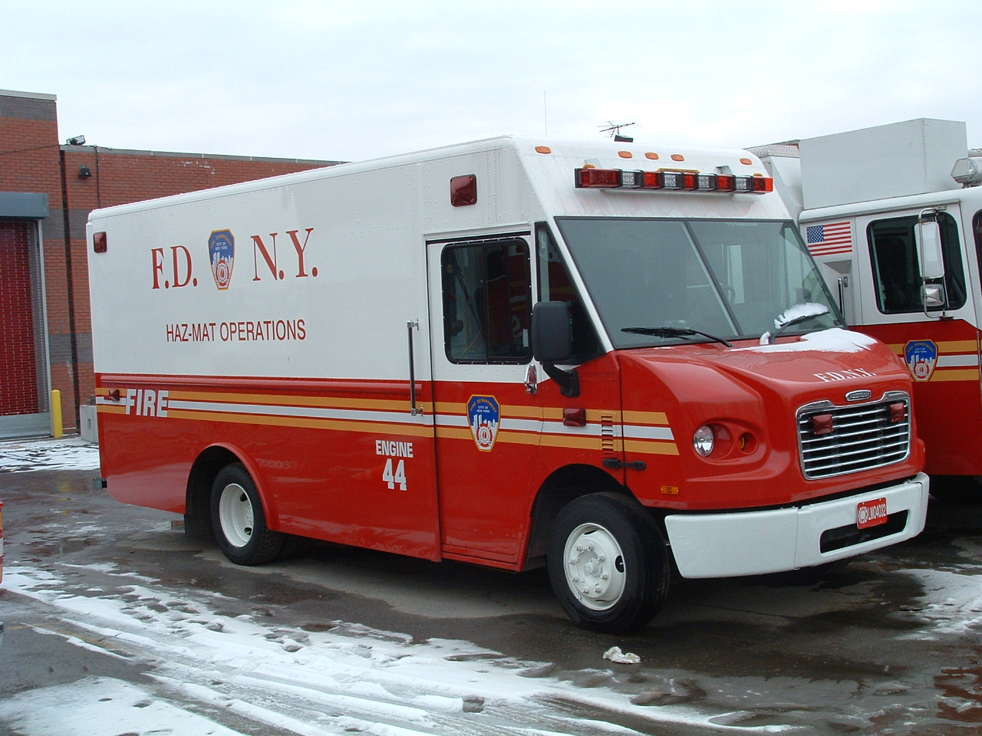

The Haz-Mat Equipment carried by the Tech Engine Company mirrors that found on the
R-5 and Squad Company apparatus. The numerous items of equipment mandate that the Company utilize a second apparatus for transport (i.e., the “tender”).

The Tech Engine HMTU’s are not trained in the Rescue Company special operations for collapse, high-angle, diving, trench and scaffold rescue. The special equipment required for these operations are not assigned or carried by the Tech Engine Support vehicles.

When the Tech Engine leaves quarters for training or other non-response activities, the Haz-Mat tender shall accompany the company. For response from quarters for other than haz-mat incidents, the tender is left in quarters. When out of quarters without the tender and assigned via radio to a Haz-Mat response, they shall notify the dispatcher to inform the IC and Haz-Mat Battalion of a delayed response.
The eight Haz-Tech company functions described above are accomplished through the utilization of tools and equipment carried on both apparatus, many of which are described as follows:

- Identification capability is enhanced by meters that reliably utilize various technologies to assist in the determination of the presence or absence of a material. The Tech Engine carries an MSA Passport five gas meter (oxygen, carbon monoxide, hydrogen sulfide, sulfur dioxide, and combustibility), an MSA photo ionization detector (designed to identify and quantify contaminants in the air), a Ludlum radiological detector, and a chemical agent and irritant gas detector. Special “single gas” meters for Ammonia, Chlorine and Hydrogen Cyanide, all commonly found gases are also carried. Additionally, identification may be accomplished by the use of chemical classifying paper and ph paper that operate in a manner similar to a litmus test.
- Control is accomplished via many items of equipment. Speedy-dry remains a staple in the ever-present “nuisance spill” department. Fibrous pads and “sausages” specifically designed to soak up or dike oils, acids, or hydrocarbon liquid spills are carried on the tender. Plastic sheets and bags remain a simple yet effective control material for a variety of materials.
- The meters described in (1) above will usually determine the quantity of a material in addition to aiding in identification. The Tech Engine will then refer to a veritable library of reference materials – most of which are textbooks - that is carried on board the tender. These references are invaluable in determining the potential hazard posed and they contain information on virtually every chemical known to man. This function is known as the “Resource Area” and one firefighter may be designated as the resource firefighter at the scene, based upon demands on the Unit. Haz Mat 1 will assume this position on their arrival or may serve in this capacity via department radio or Nextel while responding.
- Mitigation is often accomplished through clean-up. The Tech Engines carry several types of pumps and associated hoses that allow for the transfer of liquids directly into a drum (also carried by the unit, in various sizes) or other suitable reservoir. For corrosive spills, the Tech Engine carries powdered material that will neutralize the release on-scene, hastening DEP approval for safely washing the material away. The company also possesses such unique items as a mercury clean-up kit to allow for rapid control of this heavy toxic metal. In the event of a release from a breached container, the Tech Engine possesses several “leak-seal” kits with specially designed cones, plugs, and pads, some of which are pneumatically actuated, to rapidly reduce or eliminate the flow of product. In the event of unusual and challenging metals fires for which water is ineffective and dangerous (i.e., magnesium or titanium), the company carries a supply of granular material designed to smother and cool the fire.
- A variety of drums and bags are carried on the tender to over pack released liquid and solid material that can be picked up.
- The Tech Engine is fully trained to establish and maintain a functional decontamination area. The components of such an area – water supply hoses and wands, brushes, detergents, bleach, and collection reservoirs – are carried on the tender. This equipment is primarily for use with their own removal from chemical protective clothing (CPC), but can be used on other responders and civilians prior to the arrival of a Decon Task Force.

[Note: The FDNY Haz-Mat response plan utilizes 25 Decon Task Forces, each consisting of a SOC Support Ladder Company trained to a Technician I level, a Decon Engine Company trained to provide Technical Decontamination and a supervising Battalion Chief. They are geographically dispersed throughout the five boroughs to provide a quick response.]

- The Resource firefighter maintains a list of phone numbers and has been provided with a Nextel phone pre-programmed with key FDNY, City, State and Federal response agency phone numbers. The resources reached in this manner are often instrumental in the successful resolution of the incident.
- The Tech Engine has been trained to don many levels of personal protective clothing to allow for entry, identification, control, rescue, and mitigation activity in the event of an exceptionally challenging release. This includes the use of Levels A, B, and C protective clothing, all carried by the company.

“Member Safety: A benefit to all from increased Haz-Mat Trained Companies”

A Haz Mat incident is a threat to all FDNY members as well as to the general public. It is virtually assured that each firefighter will be involved in at least one Haz Mat incident of significant proportion within his or her career. Often these incidents are beyond the capabilities of the first arriving units. It is imperative that the members of the Department be thoroughly familiar with the capabilities of each of the companies comprising the Haz Mat group, so as to seek appropriate assistance or to render assistance where dictated by protocol or circumstance. A full knowledge of the FDNY response mechanism for Hazardous Materials releases will allow our rank-and-file to function confidently and within reasonably safe limits.

Sidebar:

The current levels of Haz Mat response within the New York City Fire Department are listed below. It can be expected that in continuance of the recent history of dramatic growth in the Haz Mat Group, changes will continue and Units may be added or modified to suit the needs of the Department, the city and civilians.

Haz-Mat Group Supervisor Haz Mat Battalion Chief and his Aide
Technical Specialists Haz Mat Company 1
HMTU’s [Technician II level] Seven Squad companies, Rescue 5, Three Tech Engines
Technician II Personnel Rescue companies 1, 2, 3 and 4
Medical Haz-Mat Technicians 21 Haz TAC Ambulances, ALS and BLS, trained to
support Haz-Mat technicians and triage victims in
the Hot Zone with CPC if necessary.
Technical Decon Task Forces 25 SOC support trucks, Technician 1
25 Decontamination Engines, ambulatory and non-
ambulatory victim treatment.
25 Battalion Chiefs
CPC Rescue Personnel 7 CPC Truck Companies, trained for rapid rescue of
victims in a contaminated area requiring CPC.
[Nineteen additional CPC Ladder Companies are
scheduled for training in the Spring of 2005.]

