|  |  |
| --- | --- |
| FDNY Haz-Mat 1  1984 - 2014 | Abstract  The legacy that was created by the early members of the company set the standard for others to follow. The future members of Haz-Mat can be proud of their past, maintain the respect and honor of the men who went before them and continue the tradition of constant improvement in their status and position in the Haz-Mat community.  Philip H. McArdle  An overview of the beginning – more to follow |

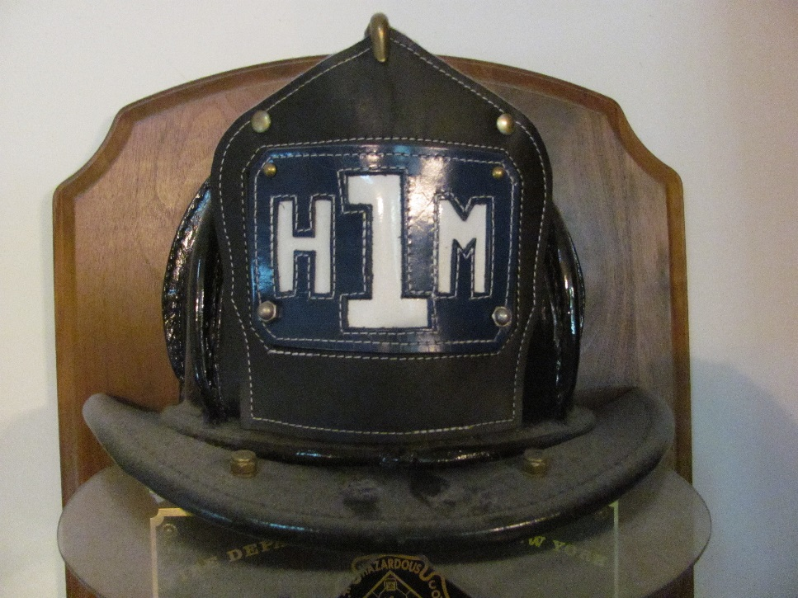

**Remembering the 9/11 Heroes of the**

**FDNY's** **Hazardous Materials Company 1**

On the morning of Tuesday, September 11th, 2001, a band of Al-Qaeda terrorists hijacked four commercial airliners from several airports in the Atlantic (East Coast) region of the United States. The terrorists flew two of those hijacked aircraft into the two towers of the World Trade Center situated in the heart of Manhattan's financial district downtown. The third plane struck the Pentagon - headquarters of the U.S. military near Washington D.C., while a fourth plane was initially destined to target either the U.S. Capitol or the White House but the passengers onboard, alerted to the fact that the hijackers intended to use the plane as a weapon fought back forcing the hijackers to crash the plane in a rural field in Pennsylvania, killing all on board.

The New York City Fire Department's Hazardous Materials Company No. 1 responded to the now dual towering inferno at the World Trade Center in Lower Manhattan as did thousands of other members of various ranks and units within the FDNY. In fact, the FDNY issued a total recall (the first ever in its history) requiring all firefighters - whether on-duty or off - to come in to work.

FDNY chiefs responding to the incident were keenly aware of the level of danger going in to this crisis and more than a few were even heard to say, "We're going to lose men on this one." This crisis was unlike any that the FDNY or any other fire department has ever faced.

Thousands were still inside when the towers collapsed. Most of those still inside were office workers but there were also several hundred firefighters as well as several dozen police officers, paramedics, EMTs and other emergency responders fighting fires and trying to evacuate office workers.

The firefighters are fondly remembered by the office workers who were fortunate enough to escape before the towers collapsed as "the men who were going up while everyone else was racing down and out of the buildings to safety."

At least 2,993 people died in the 9/11 attacks, including 343 members of the FDNY. Of that number eleven member of FDNY HAZ-MAT perished. Those 11 men were inside the South Tower (Tower 2) assisting in the evacuation of people when it collapsed.

Never in history has a HAZ-MAT team lost so many members in a single incident.

That day was the darkest in the history of NYC and one of the darkest in overall American history.

At the time of the attacks the FDNY's HAZ-MAT Company had 39 members on its roster (four officers and 35 firefighters).

The specialized outfit is based in Maspeth, a neighborhood in the New York City borough of Queens that is a mixed suburban and light industrial area. It is from here FDNY HAZ-MAT responds to incidents at any location in the five boroughs (Queens, Manhattan, Bronx, Brooklyn, and Staten Island) that comprise the 310 square mile entity that is known to the world as New York City.

FDNY HAZ-MAT shares their quarters with Squad 288. The two often work closely with one another and have a special relationship. Squad 288 which responded alongside with HAZ-MAT on 9/11 to the World Trade Center lost eight men on that dark day. The 11 men lost in HAZ-MAT and the eight lost in Squad 288 made a combined total of 19 men lost which gave the Maspeth quarters the dark distinction of having the greatest number of men lost from a single firehouse in the 9/11 attacks.

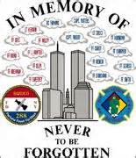

A total of 51 children – from teenagers to a 2-week-old baby in addition to some still to be born – were left fatherless when the firefighters of HAZ-MAT and Squad 288 perished.

The unit was utterly decimated by the tragedy at the World Trade Center and lost a great deal of its vital resources. The team's main HAZ-MAT response truck along with a library that included countless MSDS (Material Safety Data Sheets) and other documents as well as hundreds of thousands of dollars’ worth of high-tech HAZ-MAT equipment were buried and destroyed under the crush of rubble from the falling towers. Also destroyed were hundreds of other FDNY, NYPD and ambulance apparatus.

The FDNY was hit hard by the 9/11 disaster. Many of the 343 lost were the best and brightest of that agency. Special units as well as experienced veterans and a large portion of the FDNY leadership were killed in that single incident. It was a devastating blow for not just the FDNY but the city as a whole and for a short time put a severe strain on it's abilities to respond to disasters both man-made and natural.

All of the FDNY's elite five Rescue squads suffered heavy losses and were nearly wiped out on 9/11. However, the Rescue squads were able to refill their ranks much quicker than HAZ-MAT was able to. The FDNY's Rescue squads are a popular destination for many career firefighters. The Rescue squads and the work that they do are typically more high-profile and attractive than HAZ-MAT. Also, the subject of *qualified* candidates is an issue when it comes to recruitment for a HAZ-MAT team. There are occasions when someone will volunteer to join a HAZ-MAT team but because they don't have a fairly good grasp on basic chemistry and related concepts, they are unable to make the cut.

The surviving members of the FDNY HAZ-MAT Company noted the talent drain that was caused by the loss of nearly a dozen of its members and its leadership on 9/11. The majority of the members lost in this specialized outfit were the most experienced and senior. In fact, some of the members lost on 9/11 had been with FDNY HAZ-MAT since its early beginnings in 1983.

Many of the members of HAZ-MAT wanted to go down to the collapsed ruins of the World Trade Center and work with other FDNY firefighters to unearth the remains of those lost in the elite outfit on that tragic Tuesday morning, but city officials refused to allow them to do so. The city (as well as the rest of the nation) was on high alert for another terrorist attack, especially one involving Chemical, Biological, Radiological and/or Nuclear (CBRN) weapons and felt that it would not be a good use of HAZ-MAT - whose resources were already greatly depleted - to work at the ruins of the World Trade Center unearthing remains. There were already hundreds of FDNY, NYPD and construction workers performing that task. HAZ-MAT was a rare resource and City Hall wanted it in place to immediately respond to any CBRN attack.

In fact, while still recovering from their 9/11 losses and with their ranks greatly depleted, the specialized squad was pressed into service as never before as it responded to a series of postal-based terror attacks involving the biological weapon, anthrax, that was being used to terrorize news media centers in Midtown Manhattan as well as in other places in the nation in Autumn 2001.

CBRN terrorism was a high concern for FDNY HAZ-MAT even before the rest of the nation became concerned about it after 9/11. FDNY HAZ-MAT spent much of the late 1990's studying "exotic" HAZ-MAT incidents, namely those involving CBRN as well as studying terrorism. FDNY HAZ-MAT was also training other units in the FDNY and other city agencies in CBRN response and conducting training exercises.

In light of 9/11, the city has taken special steps to ensure that at least some of the special services provided by HAZ-MAT will still be available to the city even if the entire unit was wiped out in a terrorist attack or disaster. Outside of the HAZ-MAT unit itself, there are now 1,000 firefighters that have HAZ-MAT training. Most of those firefighters are in FDNY's Squads. The Squads, of which there are seven that are strategically stationed throughout the city, are under the command of FDNY Special Operations Command (as are HAZ-MAT and the Rescue companies) and are described as a "squad/special service company". Many of the firefighters in the Squads are trained to the technician level of HAZ-MAT response. Squads respond to HAZ-MAT incidents and assist engine and ladder companies and other FDNY units. If possible, they will resolve the incident on their own or contain the situation until the HAZ-MAT team arrives.

The Squads are also certified Rescue Technicians and are trained in all facets of technical rescue including but not limited to: structural collapse, confined space operations, high angle rope operations, trench rescue and other related rescue operation as trained by the FDNY Technical Rescue School. They possess capabilities for surface water rescue and will support rescue companies in SCUBA operations as trained Dive Tenders.

﻿﻿The Squads serve as a support force and back-up for Rescue and HAZ-MAT and if on scene, will assist them at the scene of an incident.

Because there are several Squads, they are more flexible and able to respond to disasters, often arriving at the scene long before HAZ-MAT or Rescue. The Squads serve as a support or back-up force to HAZ-MAT and Rescue on operations and are meant to fill in the void should the unthinkable happen and the HAZ-MAT and Rescue squads perish in a single incident. It almost happened on 9/11 and City Hall now understands that what was once unthinkable is not so anymore.

Today, FDNY Hazardous Materials Company No. 1 is a renewed force and continues to provide its vital services to the women and men of New York City as the city's premier Hazardous Materials Response Team.

*The Heroes of FDNY Hazardous Materials Company No. 1 who perished at the World Trade Center on Tuesday, September 11, 2001, trying to save the lives of thousands during the largest rescue operation in American history.*

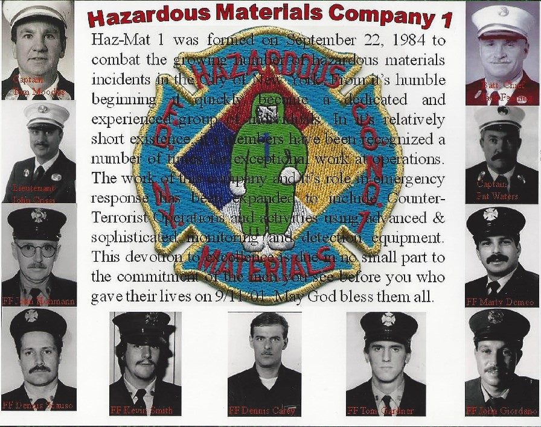

[*Chief John Jack Fanning*](http://bravestmemorial.net/html/members/fanning_john_2_bc_hazmop.html) [*Captain Patrick J. Waters*](http://www.legacy.com/LegacyTribute/Tribute.asp?Page=TributeStory&PersonId=103409)

[*Captain Thomas Moody*](http://bravestmemorial.net/html/members/moody_thomas_cpt_div001.html) [*Lieutenant John Crisci*](http://www.legacy.com/LegacyTribute/Tribute.asp?Page=TributeStory&PersonId=98346)

[*Firefighter Kevin Smith*](http://longisland.newsday.com/911-anniversary/victims/Kevin-Smith) [*Firefighter John Giordano*](http://www.firehouse.com/victim/john-giordano)

[*Firefighter Thomas Gardner*](http://qcpages.qc.cuny.edu/STC/TGFundHome.html) [*Firefighter Martin N. Demeo*](http://www.nyc.gov/html/fdny/html/memorial/wtc/demeo_martin_ff_hmc001.shtml)

[*Firefighter Jonathan R. Hohmann*](http://www.silive.com/september-11/index.ssf/2010/09/jonathan_hohmann_48_firefighte.html) [*Firefighter Dennis Carey*](http://bravestmemorial.net/html/members/carey_dennis_fr_hmc001.html)

[*Firefighter Dennis Scauso*](http://bravestmemorial.net/html/members/scauso_dennis_fr_hmc001.html)

  Never Forget!

**Rescue Services**

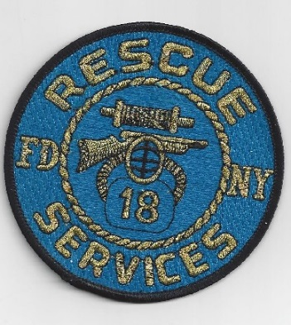 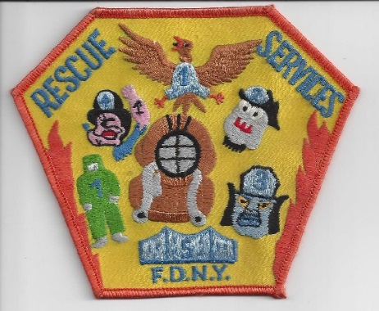

**Rescue Services was the forerunner to the Special Operations Command. Originally the 4 Rescue Companies (Rescues 1-4) operated in their respective boroughs with occasional responses to other areas. Their main work involved fire duty.**

**Rescue 1 was handling diving operations and high angle rescues; Rescue 2 was covering Brooklyn & Staten Island and was busy with fire duty. Rescue 3 was covering the collapse work and confined spaces and Rescue 4 was given the task of hazardous materials response after the George Washington Bridge Incident. A propane tank trailer (MC 330) developed a leak because of a stuck safety relief device malfunctioned; it caused a massive traffic jam on interstate 95 closing the roadway for over 12 hours. The federal government stepped in and told the city to get a Haz-Mat Team so Rescue 4 was chosen to lead this effort.**

**As time went on it became apparent that some unique situations required additional training, specialized tools and equipment, and different types of protective clothing. The Rescues were not just doing fire duty anymore, they were doing their other assigned specialized duties. This was taking them away from their primary roles of firefighting in the boroughs. The Borough Presidents, in particular Donald Mannis of Queens was complaining that Rescue 4 was spending too much time out of the borough on Haz-Mat calls and not doing fire duty in Queens. Staten Island needed its own Rescue Company because response times for Rescue 2 were too long as well; additional coverage was going to be needed.**

**Under Commissioner Spinnato and Chief Ray Brown new command would be formed: RESCUE SERVICES. This command would include a new Rescue 5 for Staten Island and a City-Wide Hazardous Materials Company 1 to be centrally located in Maspeth Queens.**

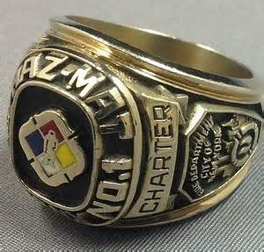 **The Charter Members**

**Today, it is extremely rare to become an original member of any NYC Fire Department Company. The original members of Haz-Mat were selected from volunteers throughout the department. Each prospective member was interviewed to determine if they had any special skills that would benefit this newly formed company before being selected. Training for these members began with 6 weeks of training at the Rock.**

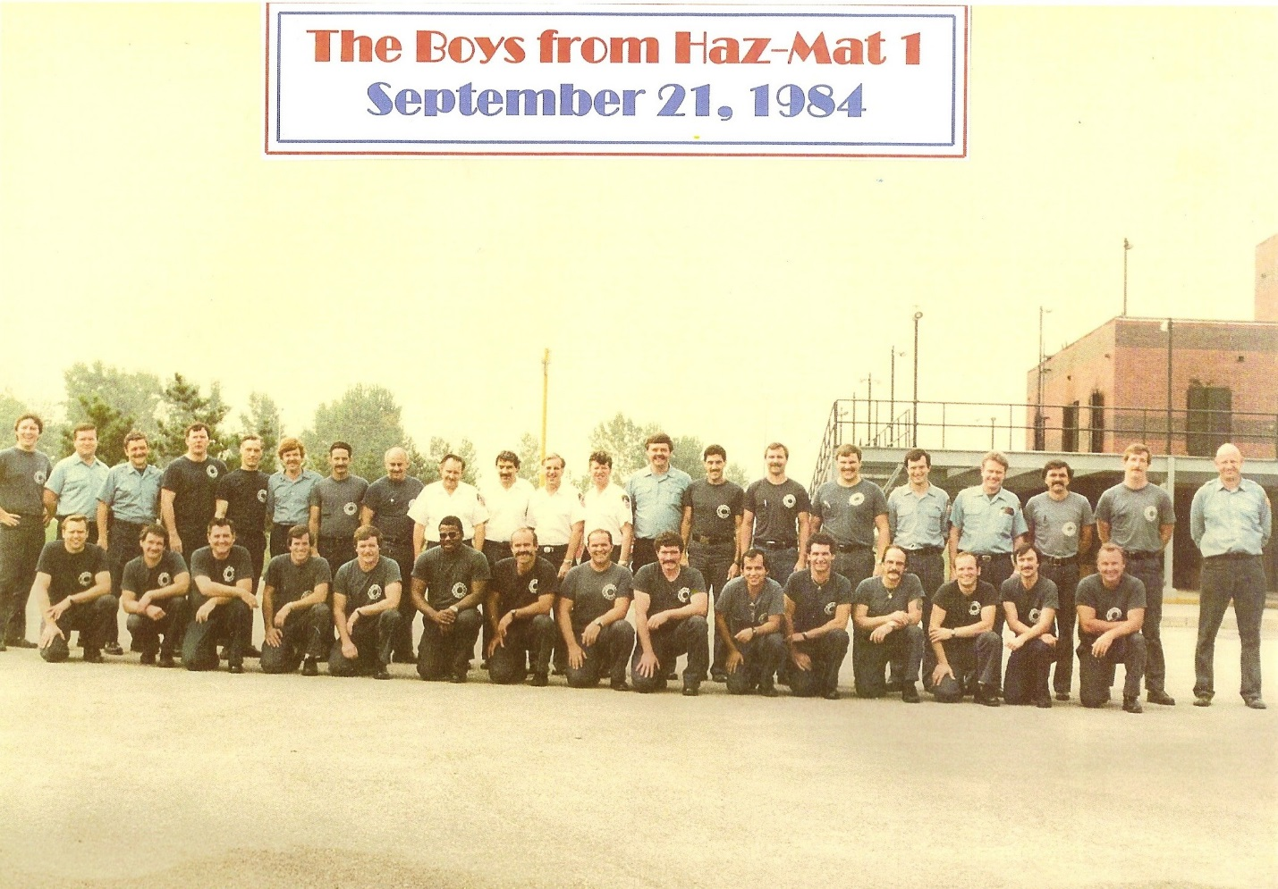

**The training was conducted by the first officers of Haz-Mat 1, Captain Joe Gallagher, Lieutenants Jack Calderone, Al Jardin, and Joe Buell in addition to members of Rescue 3 & 4 in particular Lt. John Dillon (R-4) Firefighters John Norman & Chris Waters (R-3). This was followed by members being selected to attend school at the National Fire Academy and the EPA. It soon became apparent to a few members that this training, although good was not nearly enough to adequately respond to a wide variety of incidents. During the early years many battles were fought over training, staffing, equipment, and specialization pay.**

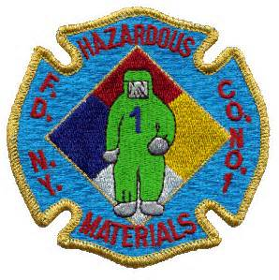

**The charter members were persistent, unrelenting, and dedicated to the pursuit of a professional Haz-Mat Team. They learned everything they could. As the new kids on the block, they had to prove themselves every day, because everyday someone was watching hoping they would falter. To their credit they excelled, they developed new tools and techniques for hazardous materials response. They worked with manufacturers to correct flaws in existing equipment, improving it. When necessary, they worked to develop equipment that did not exist. In a relatively short time, they were considered one of the premier Hazardous Materials Response Teams in the country. A number of these members went from students to instructors, course developers and content matter experts in Hazardous Materials, NBC, and Weapons of Destruction. They worked for the National Fire Academy, the Department of Justice, the Military as well as State Fire Academies around the country. Some were instructors at NASA, LSU, and did work for State Fire Marshals around the country, some even taught abroad. Phil McArdle, Vinnie Doherty, Kevin Culley, Bob Ingram, Rick Gimbl and Kevin Smith led the way as the charter members. They were followed by Dennis Scauso, Jeff Borkowski, Eddie Tomaszewski, Pete Stuebe, Jack Fanning, Tony Mussorfiti, Tim Regan, and John Larocchia. Others would follow in their footsteps.**

**The Hazardous Materials Technical Specialist Pin**

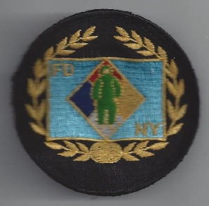 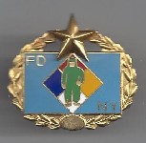

**With all this hard work and commitment came recognition. Many hours each day, when not responding was learning about, repairing, and maintaining tools and equipment. The FDNY divers were being recognized with a special pin for their uniform for their hard work and dedication so why shouldn’t the Haz-Mat members be recognized also. Firefighter John Thomas from Rescue 5 was the person responsible for getting the diver’s pin approved by the department. Firefighter Phil Mc Ardle approached Thomas and was able find out the necessary steps for getting something approved. First a design of the actual pin was made; it was modeled after the diver’s pin. A star would be added to the pin to indicate personnel who were qualified & certified to teach Haz-Mat others would receive the pin with no star. The next step was to design a list of requirements to be awarded the pin. This was completing all the required schools at the time (NYS Haz-Mat 1 & 2, National Fire Academy Tactics & Chemistry, and the EPA plus two years in the company). With the standard set McArdle wrote a report and forwarded it up the chain of command. With each endorsement came questions and additional questions and justification. In the end it was approved and McArdle was authorized to spend up to $800.00 for the purchase of 100 specialist pins. They were purchased from Hock & Mandel in Manhattan.**

**Awards for Valor & Unit Citations** 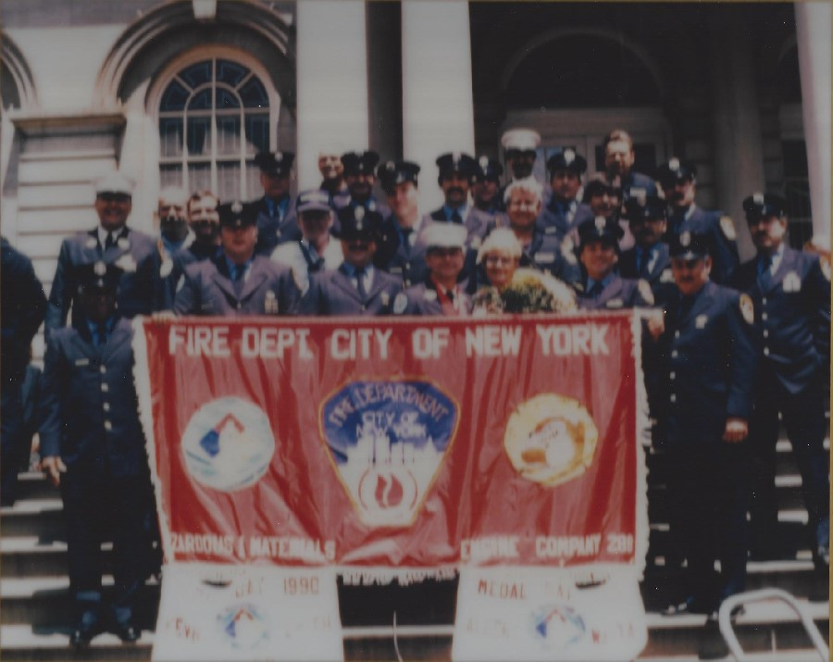

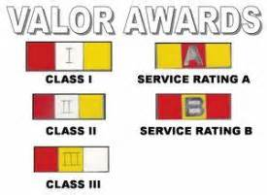 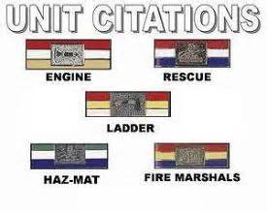

**Our first department award came in the form of a unit citation on August 14, 1985. We would receive 18-unit citations in the first 14 years of our existence. This included unit citations in all 5 boroughs. Awards of Valor were also received by our members with Lt. Al Warta & Kevin Smith receiving Class III’s for the LaGuardia Plane Crash on September 20, 1989. Bob Ingram & Phil McArdle received Service Rating “A” for a chlorine release in Manhattan in 1988 and Phil McArdle received a Service Rating “B” at the Island Transportation Tanker fire that occurred in the Bronx on May 20, 1991.**



**The Unit Citation for Haz-Mat was designed by Lt. Joe Buell. The Green was for the color of the chemical protective clothing that we wore initially. The white was for the color common to all the unit citations prior to the fire marshals designing their own. The Blue was for the original Rescue Services colors. The Crest was the same as the Rescue crest, a diver’s mask with a Lyall Gun and Rope. The Rescue crest was silver and the Haz-Mat was Gold.**

**One interesting note about the unit citation for Queens Box 22-7162. It occurred almost 9 years to the day of the George Washington Bridge incident (the incident that got Haz-Mat started in the FDNY). It involved the same product (propane) and a similar problem (a leaking safety relief device). This time, however the results would be different. Because of the training and expertise of the men of Haz-Mat 1 the incident was resolved in less than 45 minutes while dealing with almost 4 times as much product.**

**A total of 19 Unit citations were awarded as follows:**

**8/14/85 Queens Box 22-6001**

**10/20-22/85 Brooklyn Box 473**

**2/18/87 Brooklyn Box 827**

**6/15/88 Brooklyn Box 33-416**

**8/7/89 Queens Box 7162**

**8/26/89 Staten Island Box 1131**

**9/20/89 Queens Box 33-0037**

**1/31/91 Manhattan Box 0435**

**4/20/91 Bronx Box 75-8814**

**5/20/91 Bronx Box 33-4146**

**6/4/91 Queens Box 22-7162**

**6/12/91 Queens Box 238**

**3/22/92 Queens Box 0037**

**7/30/92 Queens Box 33-269**

**5/25/94 Bronx Box 2400**

**10/4/94 Manhattan Box 709**

**4/7/97 Brooklyn Box 3057**

**6/18/98 Staten Island Box 8745**

**4/7/12 Bronx Box 22-8829**

**Unit Citations were awarded for work in all 5 boroughs; of the 20 that were awarded 67 members of Haz-Mat 1 and 25 details received this award. Many Haz-Mat 1 members received multiple awards; the breakdown is as follows:**

**8 citations - FF Philip H. McArdle**

**7 citations - FF John Hack**

**6 citations - Lt. Al Warta, FF’s Tom Nouza, Kevin Smith & Rick Gimbl**

**5 citations - FF’s Tom Daly, Joe Iovino, Tim Regan & Nick Reres**

**4 citations - Lt. James Oliveri, FF’s John Olewnicki, Dave Murolo, Dennis Scauso, Kevin Culley Carl Schramm, Nat Russo, Mike Kaner & Phil Hudak**

**3 citations - Lt. Joe Nallan, FF’s Vinnie Doherty, Bob Ingram, Jimmy Hay, Fred Herman, Joe Proscia, Larry Singletary, Jeff Borkowski, Dick Keller, Richie Smith, Tom Moody & Bill Boklemann**

**2 citations - Capt.’s Jack Fanning, John Fatta, Lt. Stan Rybak, FF’s John P. Cassidy, Tom Gardner, Dominic Tralli, Sean Cotter, John Hopkins, Jim Mushlit, Ron Faessler, Scott Kirchoffer & Gil Sullivan**

**1 citation - Capt. Joe Gallagher, Lt. Joe Buell, FF’s Sidney Martin, John Larocchia, Neil Yank, Tony Confessore, Bob Hunter, Tom Merkel, Al Schwartz, John Violia, Marty DeMeo, Ed Connelly, John Cassidy, Phil Hansen, John Rudge, John Crisci, Ray Meisenheimer, Danny Pontecorvo, Bob Falzone, Chris Waters, John Norman & Jerry Zeiger, Anthony Mastropietro, & Bill O’Shea**

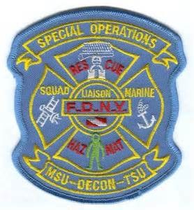 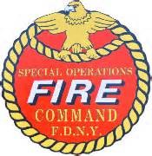

**Special Operations Command**

**As specialization was becoming more apparent, Rescue Services was handling operational issues for the 5 Rescues and the one Haz-Mat Company; however, it did not have total control of these units. Administratively these units reported to the respective Battalion Commands in which they were located. These commands didn’t understand the needs of these units; they were becoming more specialized and had to meet certain federal training requirements, in particular Diving & Haz-Mat Operations. As these needs continued to grow as well as more tools, techniques and innovations being introduced the Rescue Services Command continued to grow with more logistics and support staff. To meet these challenges under Commissioner Howard Safir a new command was established to be called the Special Operations Command (SOC). This new command (under the command of Deputy Chief James Bullock was to be divided into two main groups Rescue Operations (commanded by BC Raymond Downey) & Hazardous Materials Operations (commanded by BC Thomas J. Haring).**

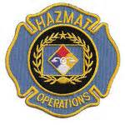

**Haz-Mat Operations**

**Chief Bullock had assigned firefighter Philip H. McArdle to assist Chief Haring in Haz-Mat operations. As the units grew in both size and responsibility, demand increased and new concepts were introduced. As an example: at one-point Haz-Mat 1 was the only qualified unit to wear Chemical Protective Clothing. This was a mere 7 personnel on duty for the entire city. When Thomas Von Essen became commissioner plans were in the works to train all the Rescue Companies, all the Rescue Operations Chiefs and the Safety Operating Battalion Chiefs in wearing Chemical Protective Clothing. This was Phase 1 of the Plan (CPC Training course) developed by Haring and McArdle (The Tiered Response). Phase 2 of the plan involved training the Chemical Protective Clothing Units (the Truck Companies & eventually the Squads), the Decon Engines and the EMS Haz-Tac units. This command (SOC) now continued to grow to its present size and table of organization. Chief John J. Fanning was the second person to command Haz-Mat Operations. During Chief Fanning’s tenure before he was lost on 9/11, he greatly improved the capabilities and response of the command. More units were added to both the Fire and EMS sides of the equation. In addition to this the logistics was vastly improved and expanded. Jack was also instrumental in getting members into the IAFF as Haz-Mat instructors and ensuring that FEMA’s NYTF-1 Urban Search & Rescue Task force was adequately represented and staffed with members from Haz-Mat 1. When Jack was lost on 9/11 a huge void was created that had to be filled. Bob Ingram, a recently promoted battalion chief and charter member of Haz-Mat 1 was selected to replace Jack. Bob was up to the task and did a magnificent job under the extreme circumstances under which he was placed. He helped rebuild what was lost and continued to improve Haz-Mat Operations. Bob transferred command to Deputy Chief Nick Delre who has continued to improve the command.**

**The Captains of Haz-Mat 1**

**One of the hardest jobs in the FDNY was being the Captain of Haz-Mat 1. It required an individual who was smart, with a willingness to persevere under adverse conditions. Someone who would stand up for the men under their command. It took a special breed of people to hold this position. They were dealing with a department heavily steeped in tradition, a department with over a hundred years of fire experience that had no idea how to deal with a new hazardous materials company. The leadership, the chief officers, who were running the department, came from fire companies, engines, trucks, and rescue companies. Their SOP’s and aggressive interior attack strategies were tried and true from many years of trial and error and experience. The Haz-Mat captain had no peers. The engines, trucks and rescues could share their experiences, they had similar problems; they could rely on each other and had similar points of view. The Haz-Mat Captain was alone, he had virtually nothing in common with other Captains on the job. The Haz-Mat Captains had different staffing, 7 more than any company in the job, their protective clothing was different, the tools they operated with were different, as well as their SOP’s, policies, and procedures. Each Day brought new challenges for the captains, especially in the early years when the department was getting used to Haz-Mat and the way it was operating.**

**Joe Gallagher was selected as the 1st Captain. One of the reasons Joe was selected was Joe was familiar with the first chemical suits used by Haz-Mat the (CP 11-11). When he was in the military, he used this clothing while fueling missiles in the Army. When Joe was promoted to Battalion Chief, he stayed in the Rescue Services Command under Chief Duffy and was replaced by Jack Fanning. The list of Captains is long and distinguished:**

**Captain Joe Gallagher (promoted to BC-DC / now retired)**

**Captain Jack Fanning (promoted to BC / lost on 9/11)**

**Captain Howie Kennedy (now retired)**

**Captain John Fatta (now retired)**

**Captain Pete Stuebe (promoted to BC / now retired)**

**Captain Brian Smith (active Squad 18)**

**Captain Vinnie Doherty (now retired)**

**Captain Patrick Waters (covering / lost on 9/11)**

**Captain Thomas Moody (covering / lost on 9/11)**

**Captain Tom Evans (covered for 12 months)**

**Captain Steve Bacci (covered after 9/11 14 months)**

**Captain Kevin Culley (now retired)**

**Captain Nick Corrado (promoted to BC - DC / active)**

**Captain John Flynn (now retired)**

**Captain Joseph Abbamonte (covering / promoted to BC)**

**Captain James D’Avolio (assigned to Terrorist Center)**

**Captain Paul Smith (presently covering)**

**The Vehicles of Haz-Mat 1**

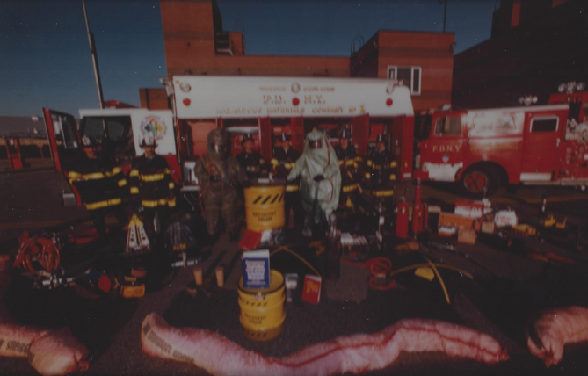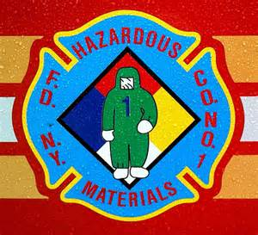**From the very beginning Haz-Mat 1 was different from most companies in the job. Almost all companies without exception operated with one vehicle. On day 1, Haz-Mat was a two-vehicle operation. It required two vehicles for two important reasons. First and foremost, it was because of the staffing, the 7 firefighters and one officer could not fit on a single vehicle. The second reason was just as valid; the large amount of equipment and expendable supplies made it necessary. Our first two pieces of apparatus were hand me downs. The 1st piece was a modified rescue rig designed by Lt. John Dillon of Rescue 4. It was purchased and intended as Rescue 4’s second piece until Haz-Mat was given to our newly created unit. The 2nd piece was a modified pumper whose hose bed was modified to accommodate supplies. It was only after these vehicles were placed in service did the members of the company start working on our own designs. Jimmy Oliveri, Tom Merkel, Rick Gimbl and Ray Meisenheimer all 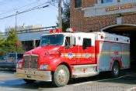worked on the design of the early vehicles. As time went on Dennis Scauso, Kevin Smith and John Cassidy contributed significant amounts of time and effort to ensure we got what we wanted. They worked tirelessly with the shops and the manufacturers reviewing and revising plans until we got things just right. Both Pete Ortel (R-3) and Charlie Ferrand from Haz-Mat 1 did the artwork and gold leaf on our early rigs. Both Pete and Charlie were terrific artists and Charlie was instrumental in the company design of our company patch. From the very first rig we acquired they all had some newly introduced tool or equipment for the job. We were the 1st 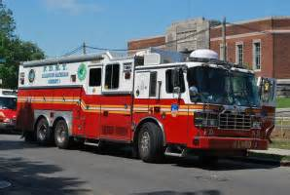to have cell phones, computers, and reference libraries. We had 5 different types of air bag systems, for plugging and patching leaks as well as heavy lifting. One of our rigs even sported a portable crane for heavy lifting. We had refrigerators and monitoring equipment for air, liquid, and solid sampling. We were definitely different from the rest.**

**The Next Generation** 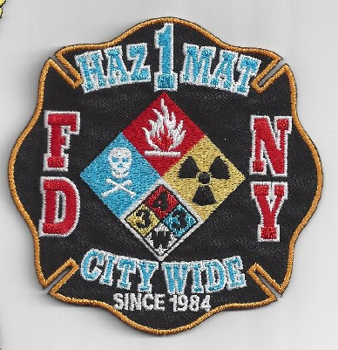

**The last original member to leave the firehouse and Haz-Mat 1 was Phil McArdle. Phil officially left March 1, 2008.**

**However, some charter members (Bob Ingram, Freddie Vargas and Jack Calderone) still remain in the job today. Bob works at the terrorism center at Fort Totten in Queens and Freddie is a lieutenant in Metro-Tech in Brooklyn and Jack is in the 22nd Battalion in Staten Island. As some of us come and go being a specialist in Haz-Mat Co.1 today requires 200 hrs. in the company plus some additional schools such as: Live Agent, Bomb School, Chemistry School, Radiological School, Highway, Rail, Tanker, etc...Today’s members are looked to for teaching the Tech 1 and Tech 2 Initials and Refreshers as well as helping structure and design a new Tech 2 refresher every year at Haz-Mat Ops.**

**Haz-Mat Co.1 has become a more integral part of the FDNY and specialization pay has helped. When in the Firehouse today they field numerous questions about hazardous materials for companies conducting building inspection. They have built a good relationship with the NSA by their work in the field. These are some examples:**

**Expeditiously removing fuel from the US Airways flight 1549,** [**Airbus A320-200**](http://en.wikipedia.org/wiki/Airbus_A320_family)**, January 15, 2009, at 3:27 p.m., that landed on the Hudson River. Other interaction with NSA was containing the fuel spill from the Metro-North passenger train derailment in the Bronx, Sunday December 1, 2013 at 7:20am.**

**The current members have also developed a relationship with FBI by backing up their findings and furthering their investigations with our members experience in monitoring and sampling. Today’s members work with other law enforcement partners as well; they have worked with US Marshals in the federal court system when they have had high profile cases. They have coordinated on site decon for possible white powder exposure and they helped train the US Marshals in Haz-Mat Tech level and to maintain their certifications.**

**The company is constantly being exposed to numerous learning opportunities at Haz-Mat Ops through advanced metering classes, cylinder classes, and robotics. New members have to spend 6 months at Haz-Mat Ops before coming to Haz-Mat Co.1 and then they have to learn all they can in a 6 month trial period. As time goes on they will strive to keep standards high through training and experience being part of the most dedicated Hazardous Materials Response Team in the world.**