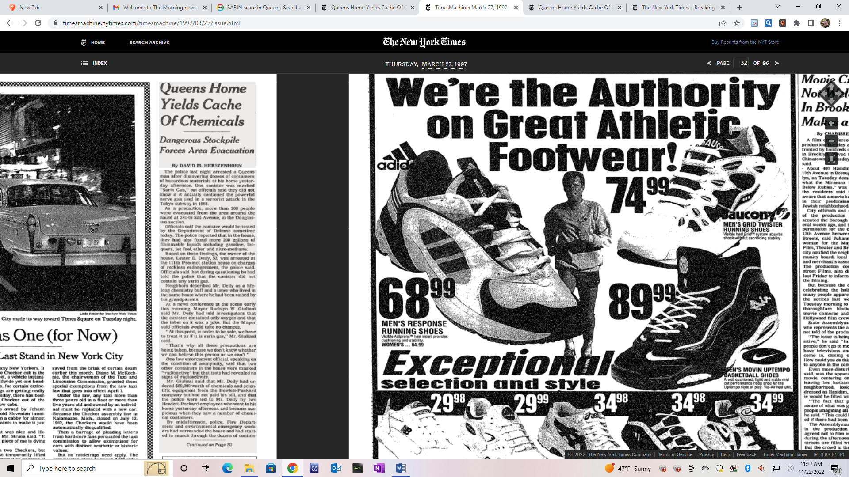 On March 27, 1997 an incident occurred in Queens that would eventually lead to a multi-agency, multi jurisdiction response to resolve a private home with a massive amount of chemicals some of which were incompatible. The incident would involve the IBM East Fishkill Semi- conductor facility (which at the time was the largest semi-conductor facility in the world handling over 4,000 dangerous and exotic chemicals on a regular basis. It would also involve the State Police as well as the US Army chemical testing facility in at Aberdeen Proving Ground in Maryland.

At this time Haz-Mat 1 was working within a new command structure where rescue operations and Haz-Mat operations were being handled differently. The first Chief of the Haz-Mat Battalion was BC Thomas J. Haring (later to become Assistant Chief and Staten Island Borough Commander) who along with Deputy Chief Jim Bullock had just been replaced a short time earlier. The Haz-Mat Battalion was being led by BC John J. Fanning III. The Rescue Battalion was being commanded by BC Ray Downey (who later became a Deputy Chief and Chief of Rescue Services.

As the evening played out it became apparent that no one was going to take any chances because one of the containers was labeled as SARIN. Sarin was a highly concentrated pesticide developed back in 1938 by I.G. Farbin chemicals in Nazi Germany. The word Sarin comes from the first initial of the last names of the development team. BC Jack Fanning called the home of Philip McArdle because he wanted him to respond to the scene. As luck would have it, McArdle was only a short distance away taking a CPR refresher class at Fort Totten. He was notified by the CPR staff to report to Chief Fanning at the command post forthwith. Fireman Phil McArdle was detailed to the newly formed Haz-Mat Battalion in order to help them set up the command. Upon his arrival he found the Chief and reported in. Everything was a little chaotic as it usually is with large scale operations involving multiple agencies.

The most pressing problem however, was going to be this liter size container labeled SARIN that would have to be removed and transported to a Military Testing facility. While several options were being discussed (ground travel or air travel). Road travel to the facility would take the better part of 4 hours whereas travel by police helicopter would take half that time. There was concern that if the container leaked during the transportation phase of the operation, the crew might become incapacitated and the aircraft would crash.

A simple solution would be a containment vessel capable of rough handling without losing container integrity. At the time the City of New York had none. The question now was who had one, could we be allowed to make use of it, and was it readily available. It was suggested that IBM facility might have one. Phil McArdle was instructed to call his longtime friend Kevin Fogerty who worked as an Emergency Control Specialists at their semi-conductor facility in East Fishkill NY and see if it was possible to acquire a container. The facility was a good 75 miles away. After a few minutes of discussion with Kevin, it was determined that they had what we needed but he would have to get permission for the containment vessel to leave the facility. A short time later Keven called back to say that was okay and he would bring down the cylinder. To ensure a safe and speedy delivery of the containment vessel, it was arranged for the vessel to be brought down under State Police escort. While waiting for the containment vessel to arrive, other containers inside the house were being segregated and inventoried and separated by compatibility by Haz-Mat 1 members.

From the initial call to the arrival time of the containment vessel it was approximately 1 hour and 45 minutes. When it arrived Kevin gave a short briefing on its use before being employed by the members of Haz-Mat 1. Once the suspected SARIN container was safely loaded into the containment vessel. It was whisked away by a police highway unit to rendezvous with an NYPD helicopter from the aviation unit. The helicopter would then fly to the Army’s Aberdeen Proving Ground in Maryland (approximately 185 miles away) for analysis.



The incident at this point was beginning to wind down. Haz-Mat 1 had finished most if not all of its work. The police investigators would be working for quite some time gathering and cataloging evidence. The residents who had been evacuated earlier, were now being allowed back into their residences.

Before leaving for the evening, Fire Commissioner Tom Von Essen called firefighter McArdle to join in a conversation that Von Essen was having with the Mayor Rudolf Giuliani.

The mayor wanted to know why we didn’t have these containment vessels in our inventory. It was explained that up until this point we never had a need to have them. He then directed me to go out and get them because he didn’t like the fact that we had to rely on outsiders (aka IBM) supplying us with equipment. After the conversation I immediately told BC Jack Fanning what had just transpired. Chief Fanning went over and spoke to them and I went home.

The very next day when reporting for work at the Brooklyn Navy Yard work was begun on the project. The Haz-Mat Battalion was sharing office space with the Chief of the Marine Division at the time. As directed I began to research the containment vessels. It was determined that the company that manufacturers them was a short distance away in New Jersey. I contacted the company and after a brief discussion it was determined

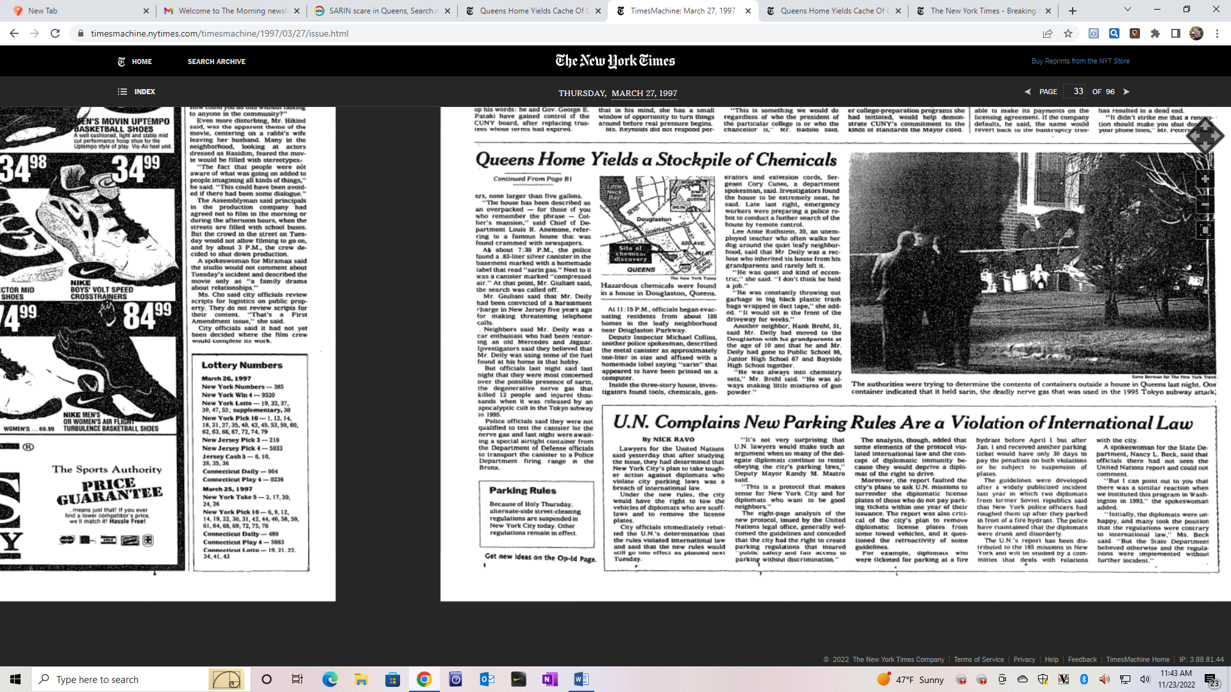

***(Left to right: Fire Commissioner Tom Von Essen, Phil McArdle and Mayor Rudolf Giuliani discussing the purchase of the containment vessels)***

that they made four (4) types of containment vessels in different metals. (Carbon steel & stainless Steel). The largest of these containers was capable of holding an “H” type compressed gas cylinder. At this point both Chief Fanning and I just considered this a research project because when the department found out the costs of these containers we felt the project would be cancelled. Early that afternoon we received a call from headquarters regarding the containment vessels. They wanted to know the status of the research and if the containers had

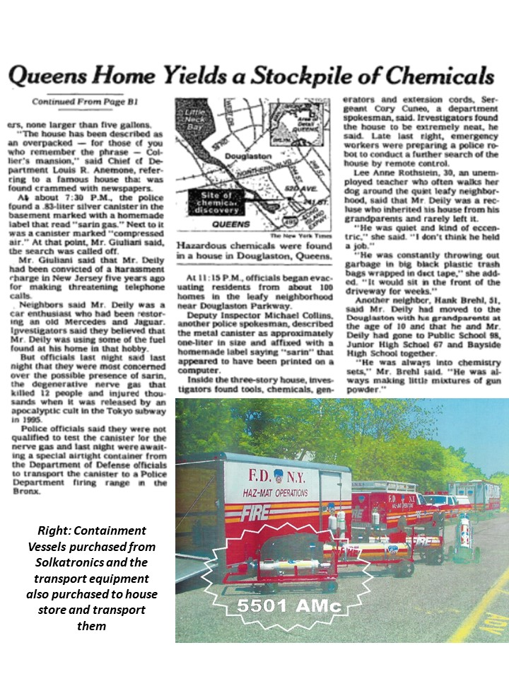

been ordered. It was explained that the vessels came in various configurations, sizes, weights and construction materials. We had no idea which of the eight the department wanted to order. We were told to order one of each type for a total cost exceeding $200,000.00. We were told to call back Solkatronics and ask them if they would accept a purchase order for the items, Solkatronics happily agreed. They sent us an itemized list of the vessels and their descriptions. The list was forwarded to Deputy Commissioner for Finance Bob Scott’s office.

When discussing this order with headquarters it was also mentioned the logistical problem of transporting these vessels to and from emergency scenes. The larger ones were too big and heavy to be placed on fire apparatus. The solution was the shops would provide two tow vehicles and two trailers would be purchased. Ed Beban of Rescue 3 was doing double duty as a logistics specialist for the newly formed Urban Search & Rescue Task Force. Beban & McArdle worked with Congelosi Trailer in Montgomery New York to acquire the trailers. One trailer was set up with the carbon steel containers and the other was set up with the stainless steel.