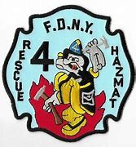

HazMat History:
The Rescue 4 AKA Haz-Mat Team
The John Dillon Years, 1980-1984
By Joe Schneiderman

In loving memory of my friend, Lt. John Dillon.
On Friday, August 8, 1980, was a little-known landmark day in FDNY history. A propane truck (DOT MC 330 9,000 gallons ) suffered an accident on the approach to the George Washington Bridge-and began leaking propane.
The first due Engine Company (Engine 93) had requested Rescue Company 4 special-called from Queens. Rescue 4’s members, including Captain Norbert Meehan and Firefighter Richard Rewkowski, successfully stopped the leak with a plumber’s test plug. The incident later made the cover of WNYF magazine.
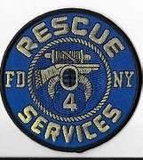
As a result of Rescue 4’s skill and ingenuity in stopping the leak, the Department designated them the citywide Hazardous Materials (Haz-Mat) team. Chief Homer Bishop at Queens Borough Command worked to set it all up. Rescue 4’s selection was logical given their proximity to and experience with incidents at industrial and chemical plants in Long Island City-and radioactive waste passed through Queens from Brookhaven National Laboratory. Also included in this consideration was Rescue 4’s close proximity to the major roadways connecting the 5 boroughs. Indeed, Rescue 4 always carried chemical suits.
Lt. John “The Duke” Dillon, who came to Rescue 4 in 1977, was the founding father of Haz-Mat team. Indeed, Lt. Dillon recalled that he organized the HazMat team “from scratch.”
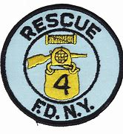
Lt. Dillon obtained all the manuals on Haz-Mat he could and his members learned about Haz-Mat through a combination of experience and formal training. This method by the time Lt. Dillon took the members to formal training at the National Fire Academy located in Emmitsburg Maryland in 1982, they were more knowledgeable than their instructors!
Rescue 4’s roster soon expanded from 25 to 35 members; they rode with seven members every tour. As a result of staffing all members redlined with overtime. Mike Milner was among the new members who came to Rescue 4 because of the expanded role. Firefighter Jessie Bilboa was another member who took on the company’s new role.
The department even issued Rescue 4 a second piece of apparatus, a heavy-duty pickup truck with a box. Lt. Dillon worked to build the second piece and designed a new, more sophisticated successor piece.
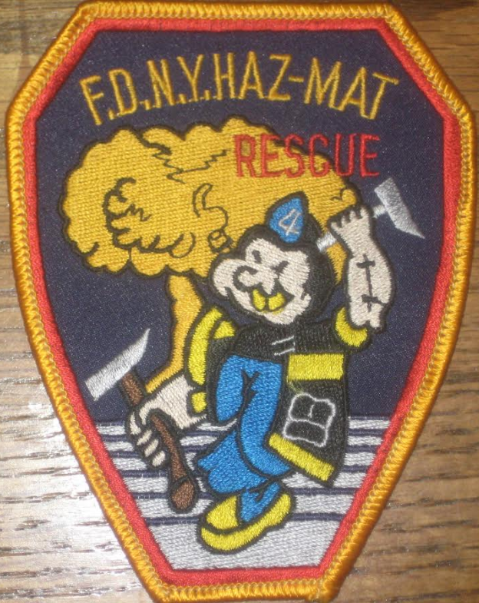
Rescue 4 even designed a special patch for their role as the HazMat team. While many are familiar with the variant of the classic patch with Popeye wearing chemical coveralls, another patch exists with Popeye in his iconic pose in front of a mushroom cloud!
Rescue 4 saw their share of real workers during those years. However, Lt. Dillon would later fondly recall one unusual incident in Manhattan. One morning, the companies had responded to a number of abandoned barrels on Manhattan’s West Side. The barrels had labels for PCBs, or polychlorinated biphenyls; an exceptionally toxic substance that attacks the immune system and causes cancer.
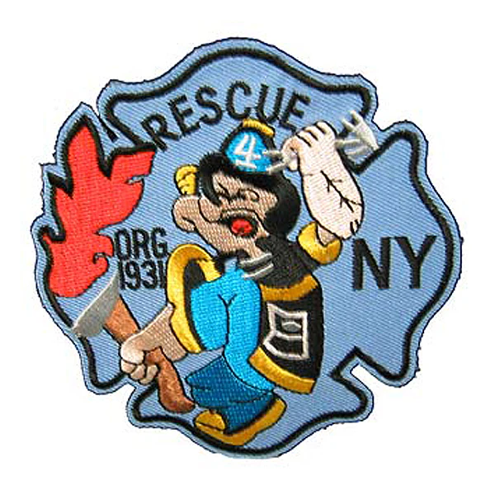
Lt. Dillon and the members treated the incident as a drill, put on their chemical suits, dealt with the barrels, and did full decontamination procedures. When Lt. Dillon returned to quarters, the Press Secretary called. The members had actually been dealing with Channel 7’s empty props for an expose that longtime New York television anchor Ernie Anastos was doing on Hazardous Materials!
Three developments would eventually help spin the Haz-Mat team off into their own company in 1984. As Lt. Dillon recalls, one was a run in the Bronx, the others were when “the union and City Hall became aware and began to take notice” of Rescue 4 operating as the Haz-Mat team in other boroughs for extended periods of time. The Queens Borough President, Donald Manis, also complained that Queens was being stripped of its only Rescue Company to answer Haz-Mat calls in other boroughs. Although some members left, Lt. Dillon opted to stay at Rescue 4, the company was now seeing greatly expanded fire duty throughout the 1980’s.

