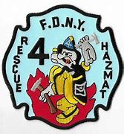
While 1981 was the start of a new era in heavy fire duty for Rescue 4, it was also the start of a new era in Rescue 4’s specialized repertoire of knowledge and equipment. While the Rescue had always carried chemical suits for chlorine leaks that would occur in Long Island City, in 1981, they were selected to be the Hazardous Materials [HazMat] Team for the F.D.N.Y. Rescue 4 was selected in part because radioactive waste would be transported through Queens from Brookhaven National Laboratory on Long Island. Another reason was that Rescue 4 successfully stopped a leaking Propane Tanker from exploding in Manhattan; by using a plumber’s test plug. Lieutenant John Dillon was selected to head and organize the team, which he started “from scratch.”
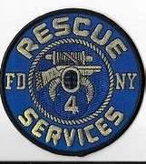
Lieutenant Dillon “wrote up everything on it, I constantly carried books on chemicals. We built up the second piece [firefighting vehicle that the department provided], I also worked designing apparatus [specifically for Haz-Mat].” While the team was “built on experience”, Lieutenant Dillon brought the members and officers of Rescue 4 for additional formal training. “We went to the National Fire Academy and spent two weeks there in 1982. We actually knew more from our hands-on experience. We also went to Safety Systems Corporation in Florida and worked with Captain Ron Gore from the Jacksonville, Florida Fire Department. We learned almost nothing.”
As a result, Rescue 4’s roster expanded to 35 men, and Lieutenant Dillon recalls that everybody “got overtime and eventually were redlined with overtime.” The Haz-Mat status also attracted new members, such as Firefighter Michael Milner, who would eventually retire as Senior Man in Rescue 4 with the most time on the job, in 2002.
While Rescue 4’s Haz-Mat Team had their share of real workers and fires, Lieutenant John Dillon recalls one particularly interesting occasion when they went to work.
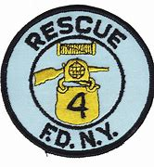
“We had a run to the West Side of Manhattan. The companies were waiting, and there were some barrels of PCB’s [polychlorinated biphenyls, exceptionally toxic chemicals] with skulls and crossbones. We looked at it like a drill, the guys got into their suits and we did a full Decon [decontamination procedure]. We thought the barrels were empty. Later, I got a phone call from the Press Secretary, John Mulligan. Those barrels were a prop for Channel 7 who was doing an expose on Hazardous Materials! Ernie Ernastas and his crew had dumped them and on the West Side!”
Because Rescue 4’s HazMat team had been organized so informally, some opposition was voiced within the company. Ultimately, the Hazardous Materials team became its own company after, according to Lieutenant Dillon, “the union and City Hall became aware of it.”

